# 

**ABOUT US**

We Farhan Woods Company is one of the oldest wooden company in Karachi, Pakistan and has been serving for 22 years. We have been manufacturing wooden items for more than a decade, and have a range of products that suit every need. From wooden doors to windows, door frames (choghats), jas iron frames, panel doors, flush doors etc. we offer them all! Our team is highly experienced and always up to date with the latest techniques.

**WHY CHOOSE US?**

## Excellent dimensional stability

In dry or wet weather there will be hardly any shrinkage or expansion of the door panels. The inner and outer points are not visible; they are made using hydraulic system and special resins.

## Stable to ultraviolet & infrared rays

The stability of door panels and frames was checked by exposing them to direct sunlight, heat and rain for four years. No change in the color or any failure in the material was observed, proving that they are very stable.

## Durability

These doors are immune to any bacterial growth, fungi, and pest and notably to termite attack. They are washable with mild detergents to their original appearance. These characteristics are of lifelong durability.

## Color choice

A variety of colors are available e.g. White, Off-white, Blue, Yellow, Ivory, Pink or any other shade can be produced by our skilled professionals, as per choice of the customer.

## Doorframes (choghats)

We design and fabricate fiberglass doorframes (choghats) of any size with excellent physical properties. We also fix doors with steel-frames, which are already installed during the construction of buildings.

Our technicians fix doors on site at nominal charges.

## Page 2~9

**Contents**

**Premium Doors**

## Page 10

#### Commercial Doors

**Doorframes**

## Page 12-13

**Wall Panels**

## Page 14-15

**Kitchens**

## Page 16

**Bed Sets**

## Page 17

**Wardrobes / Cupboards**

## Page 18-19

**Main Gates**

## Page 20

**Guard Rooms / Check-Posts**

## Page 21-23

**Pre Fabricated Cabins & Huts**

## Page 24

#### Fiberglass Pultruded Proles & Channels

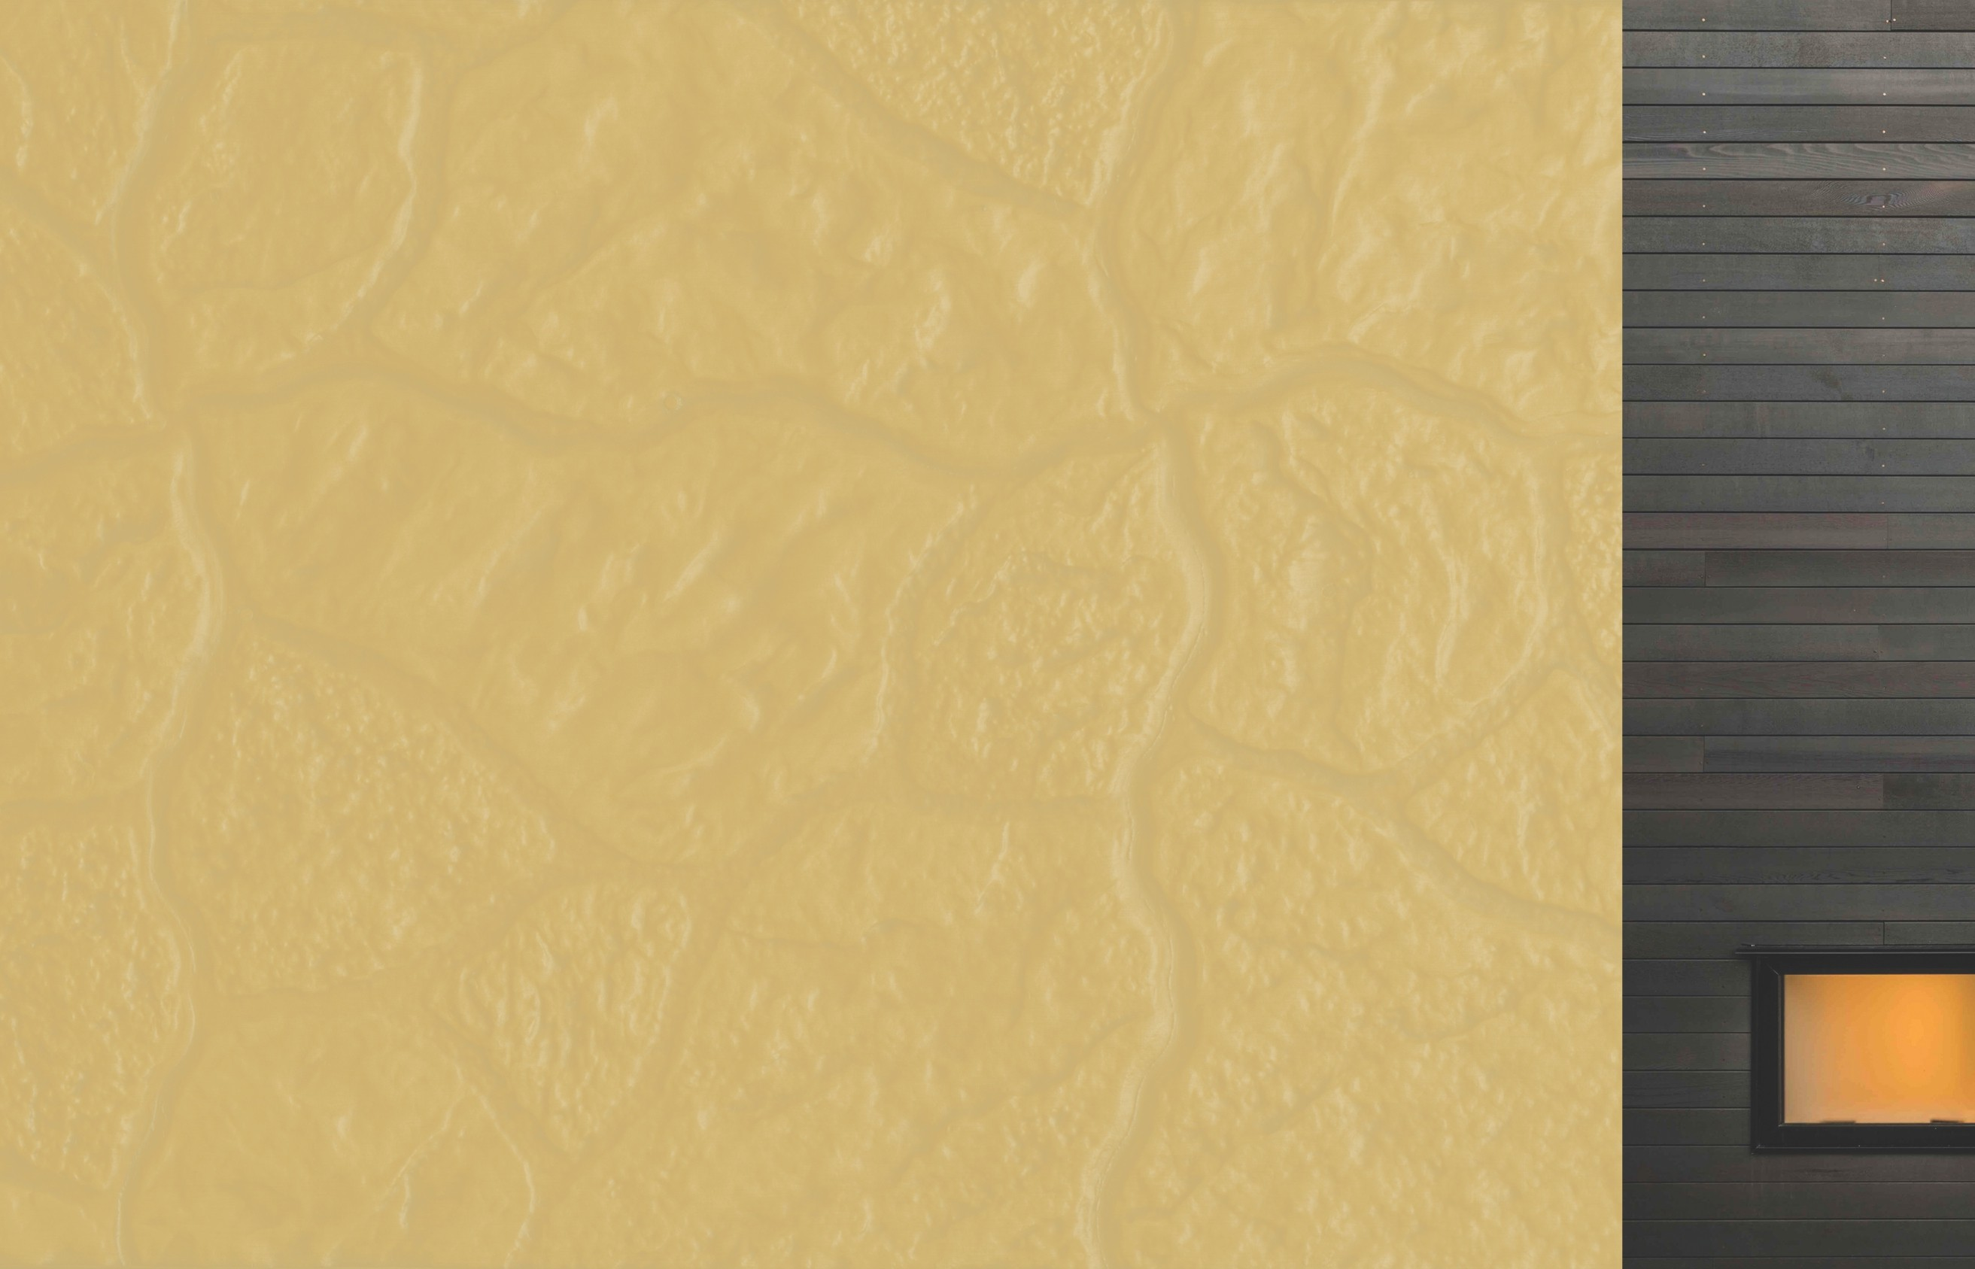

01

**Art # 010**

**Art # 011**

# PREMIUM QUALITY COMPOSITE DOORS

Composite materials offer greater strength, durability and insulation. The new composite materials are also environment-friendly and cost-effective.

#### A perfect amalgam of designs, quality and class.

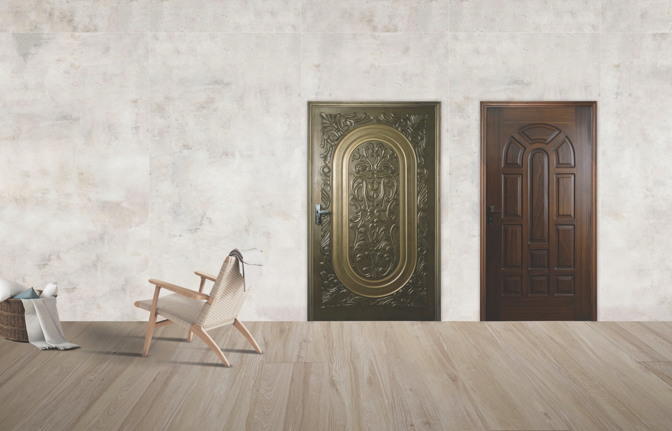

02

Maximum size:

**45” x 87”**

Minimum size:

### 43” x 84”

Maximum size:

### 47” x 84”

Minimum size:

### 24” x 74”

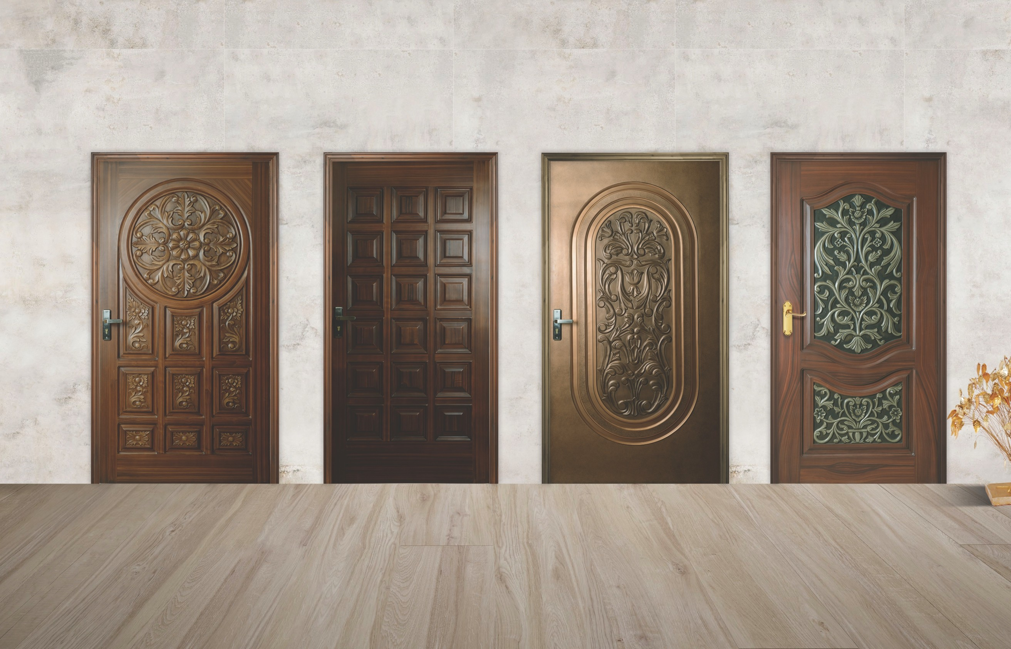

**Art # 012**

**Art # 014**

**Art # 015**

**Art # 020**

|  |  |  |  |
| --- | --- | --- | --- |
| Maximum size: | Maximum size: | Maximum size: | Maximum size: |
| **47” x 96”** | **47” x 95”** | **45” x 87”** | **45” x 87”** |
| Minimum size: | Minimum size: | Minimum size: | Minimum size: |
| **24” x 75”** | **22” x 75”** | **39” x 72”** | **25” x 75”**  03 |

**Art # 025**

**Art # 030**

**Art # 035**

**Art # 040**

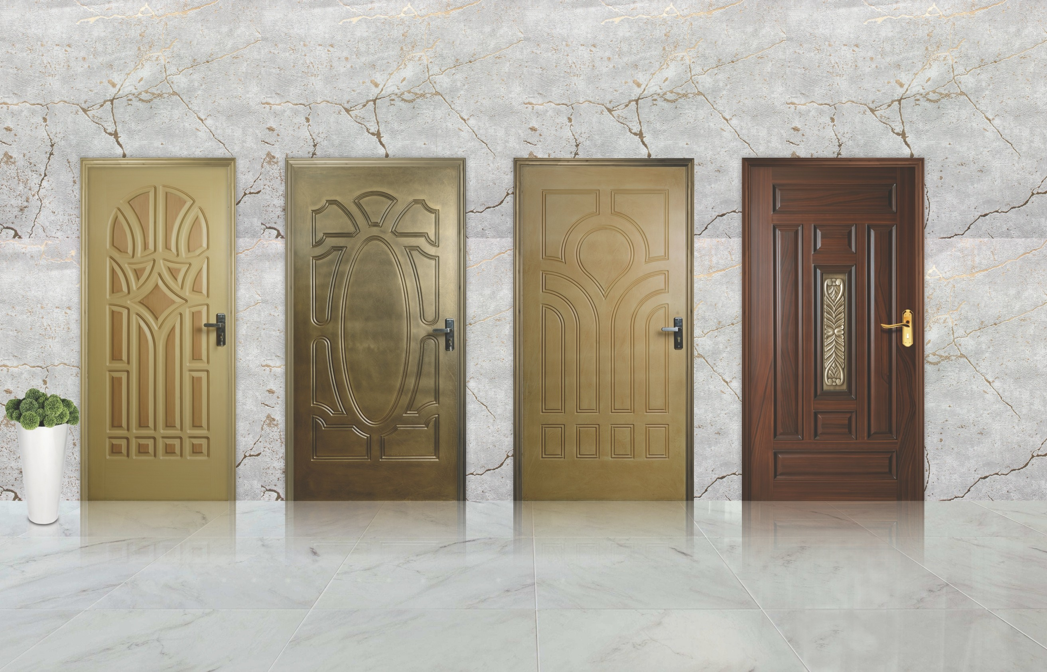Maximum size:

### 45” x 84”

Minimum size:

### 24” x 72”

04

Maximum size:

### 44” x 83”

Minimum size:

### 24” x 75”

Maximum size:

### 44” x 83”

Minimum size:

### 24” x 75”

Maximum size:

### 47” x 96”

Minimum size:

### 25” x 77”

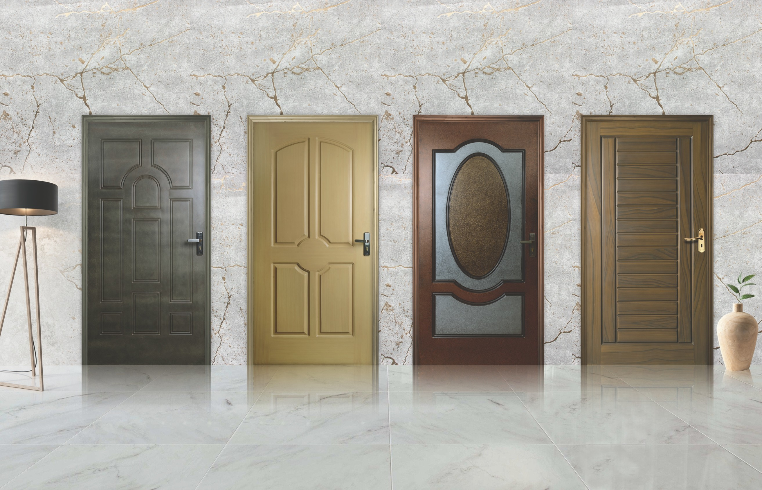

**Art # 045**

**Art # 050**

**Art # 055**

**Art # 060**

|  |  |  |  |
| --- | --- | --- | --- |
| Maximum size: | Maximum size: | Maximum size: | Maximum size: |
| **44” x 83”** | **45” x 84”** | **44” x 83”** | **47” x 96”** |
| Minimum size: | Minimum size: | Minimum size: | Minimum size: |
| **24” x 75”** | **26” x 73”** | **24” x 75”** | **25” x 75”**  05 |

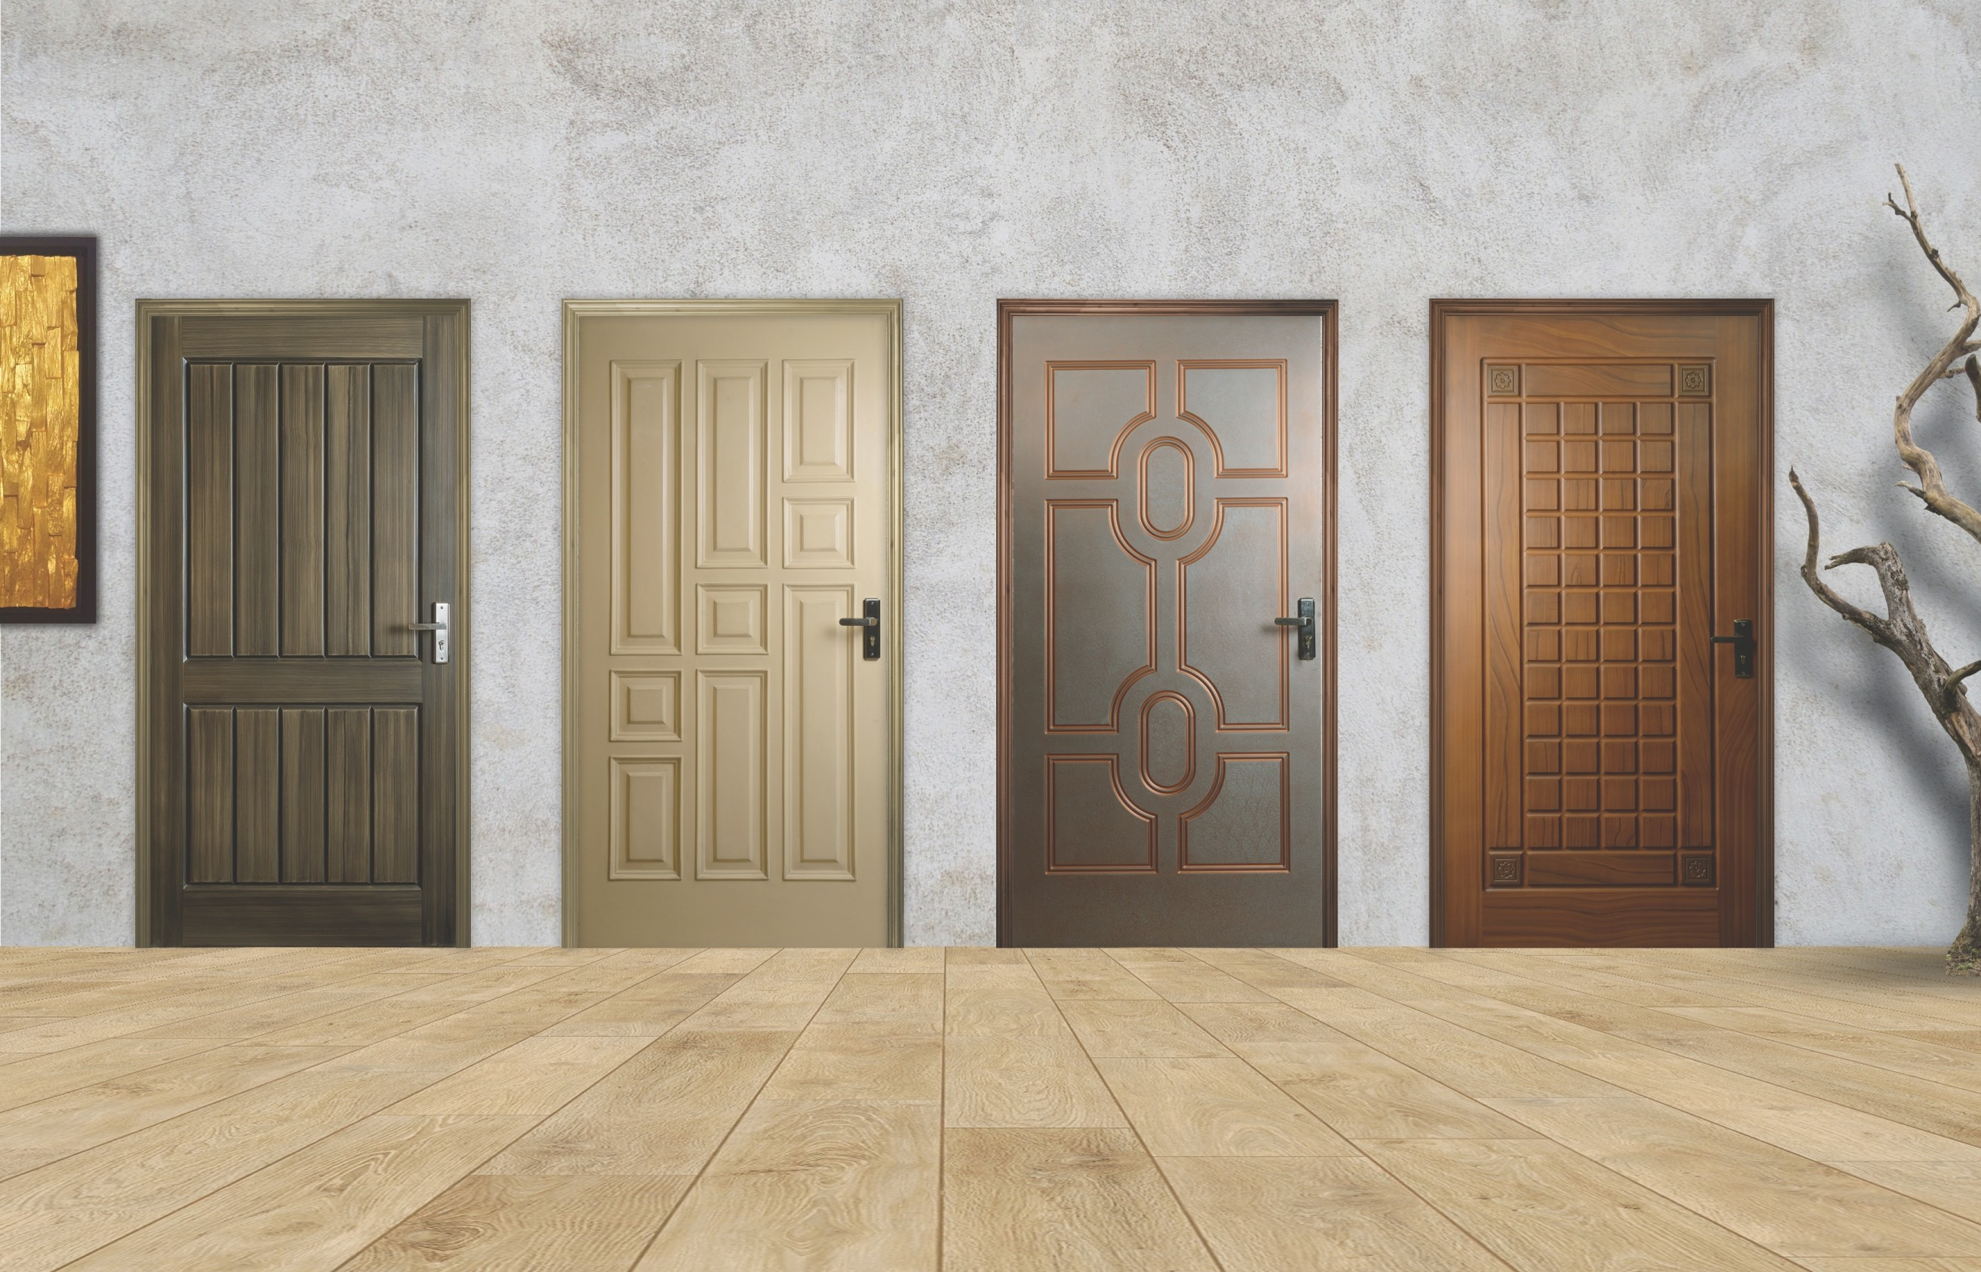

**Art # 065**

**Art # 070**

**Art # 075**

**Art # 080**

|  |  |  |  |
| --- | --- | --- | --- |
| Maximum size: | Maximum size: | Maximum size: | Maximum size: |
| **47” x 90”** | **47” x 84”** | **44” x 83”** | **47” x 90”** |
| Minimum size: | Minimum size: | Minimum size: | Minimum size: |
| **25” x 75”**  06 | **27” x 75”** | **24” x 75”** | **24” x 75”** |

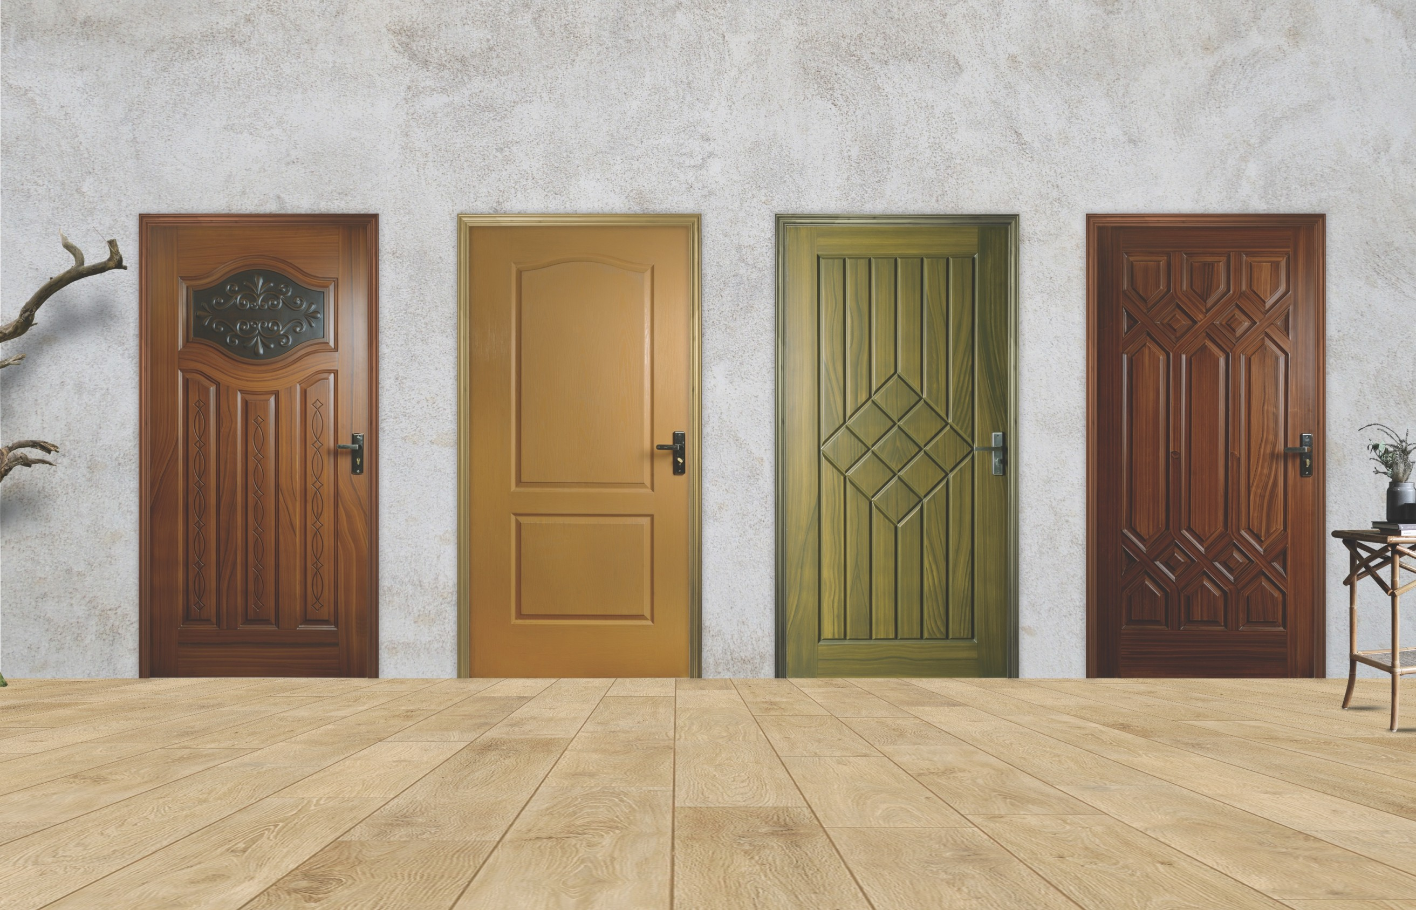

**Art # 085**

**Art # 090**

**Art # 095**

**Art # 100**

|  |  |  |  |
| --- | --- | --- | --- |
| Maximum size: | Maximum size: | Maximum size: | Maximum size: |
| **47” x 90”** | **41” x 82”** | **47” x 96”** | **47” x 84”** |
| Minimum size: | Minimum size: | Minimum size: | Minimum size: |
| **24” x 75”** | **26” x 73”** | **24” x 76”** | **24” x 75”**  07 |

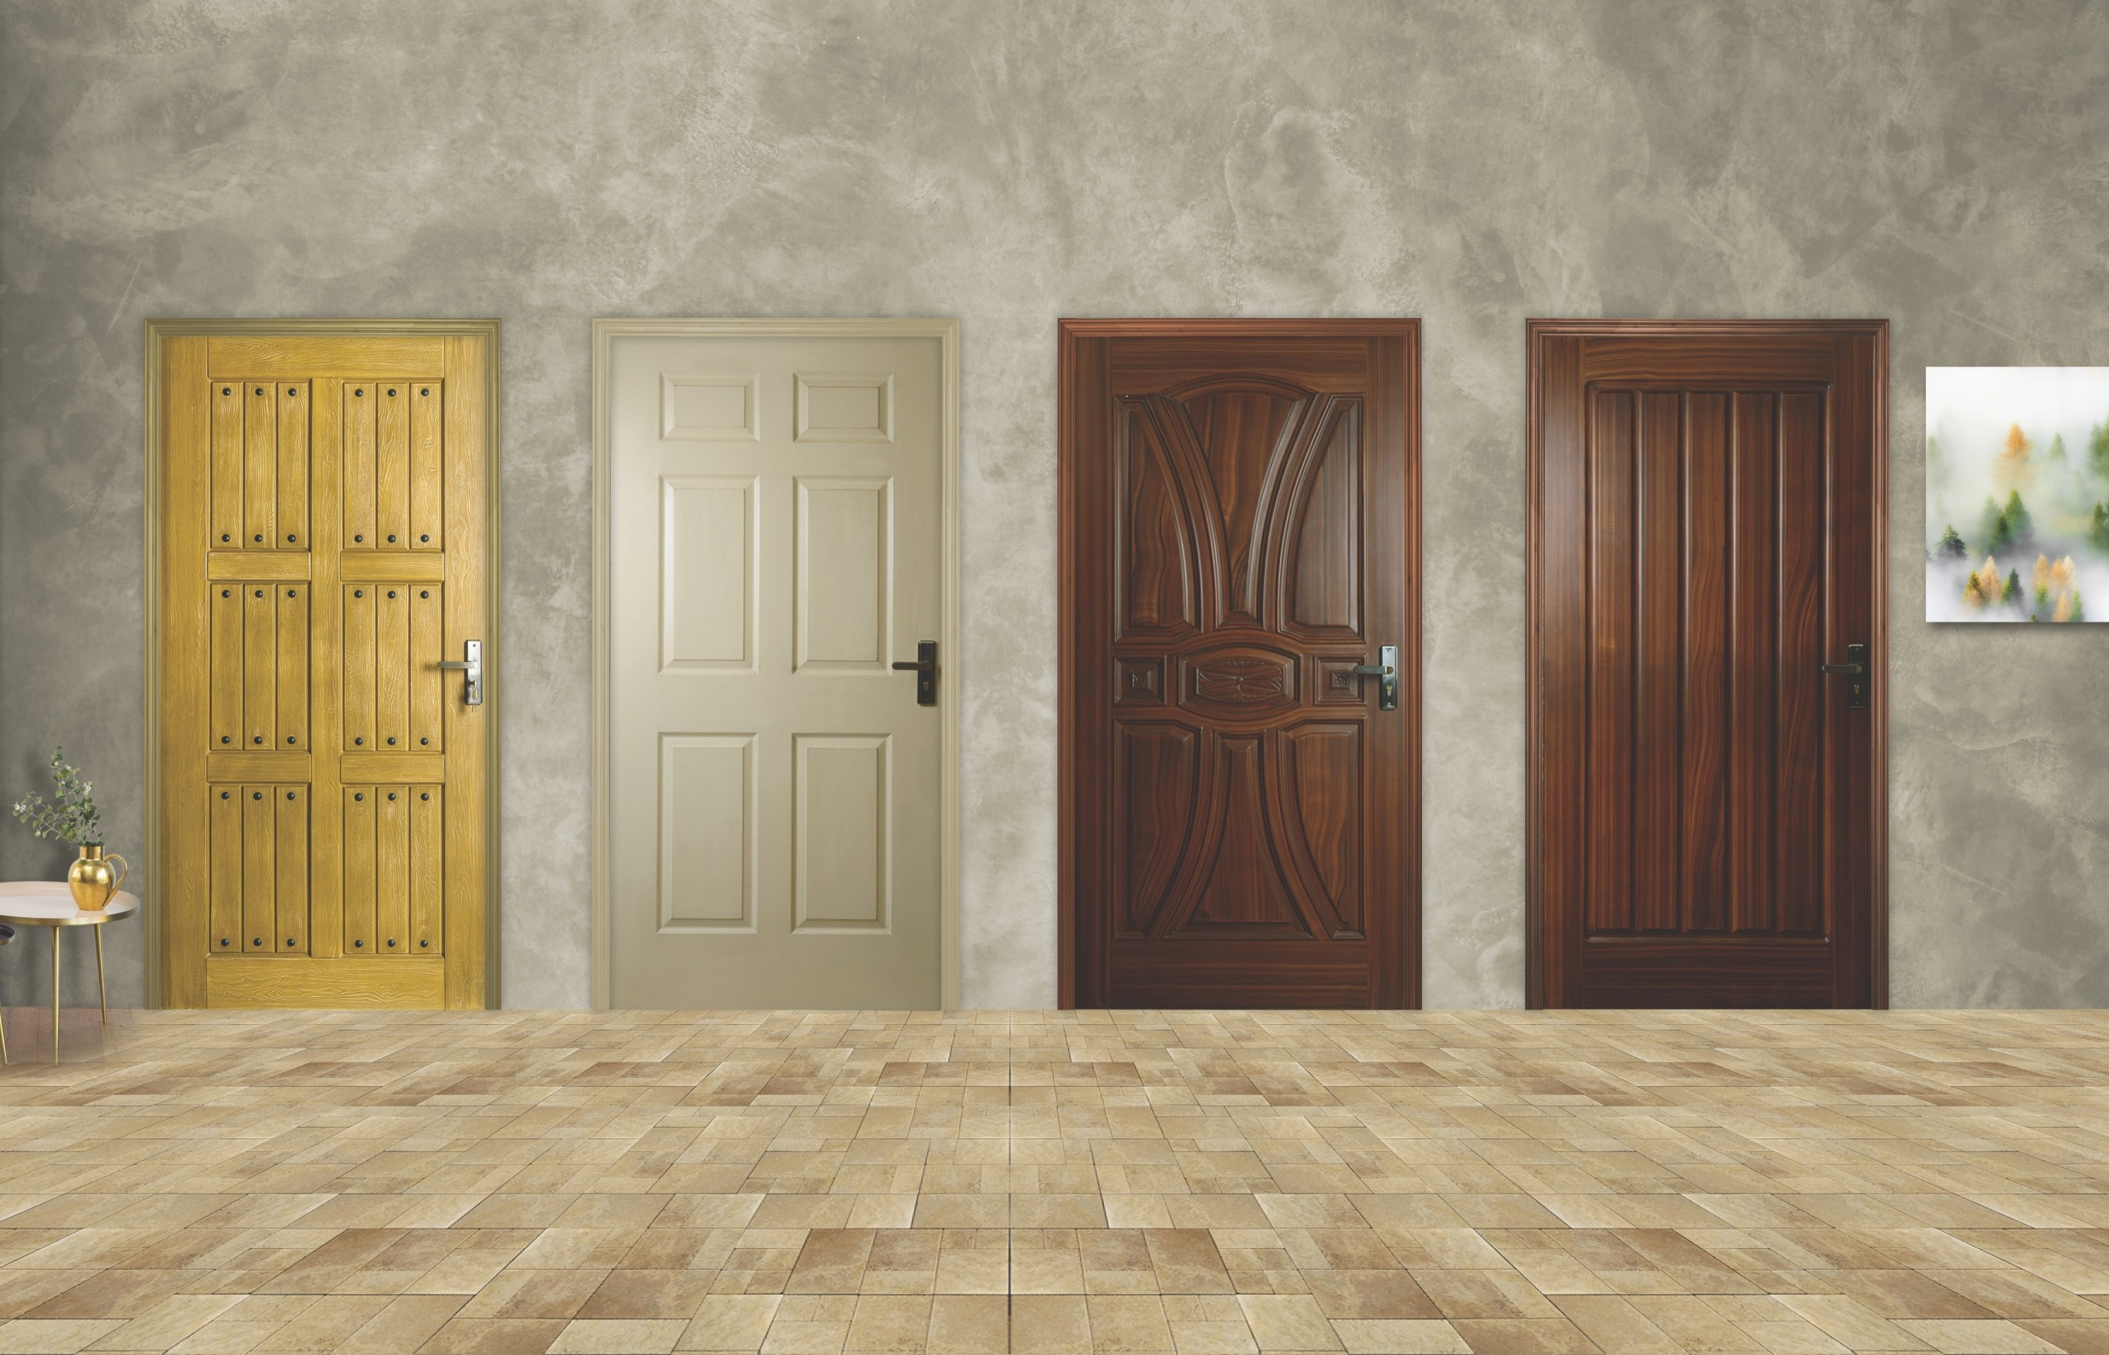

**Art # 105**

**Art # 110**

**Art # 120**

**Art # 125**

|  |  |  |  |
| --- | --- | --- | --- |
| Maximum size: | Maximum size: | Maximum size: | Maximum size: |
| **47” x 95”** | **42” x 82”** | **45” x 84”** | **45” x 84”** |
| Minimum size: | Minimum size: | Minimum size: | Minimum size: |
| **24” x 76”**  08 | **25” x 78”** | **26” x 75”** | **27” x 75”** |

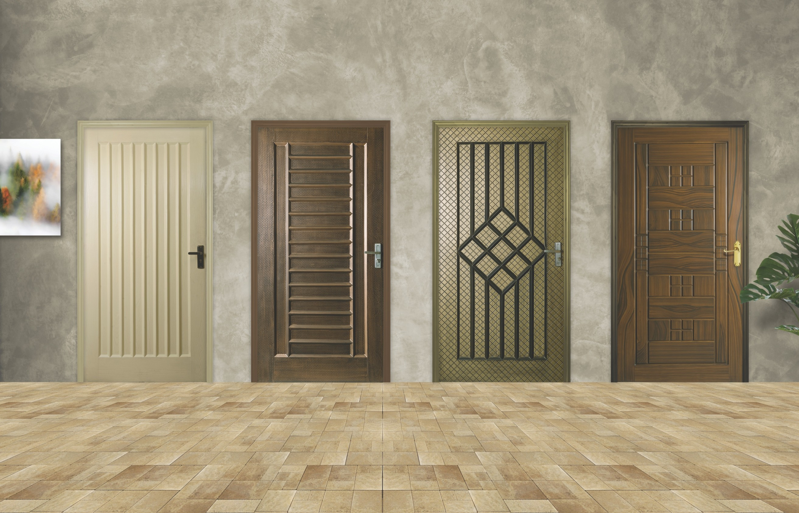

**Art # 130**

**Art # 135**

**Art # 138**

**Art # 142**

|  |  |  |  |
| --- | --- | --- | --- |
| Maximum size: | Maximum size: | Maximum size: | Maximum size: |
| **45” x 84”** | **45” x 84”** | **45” x 87”** | **47” x 87”** |
| Minimum size: | Minimum size: | Minimum size: | Minimum size: |
| **24” x 75”** | **24” x 75”** | **24” x 75”** | **24” x 75”**  09 |

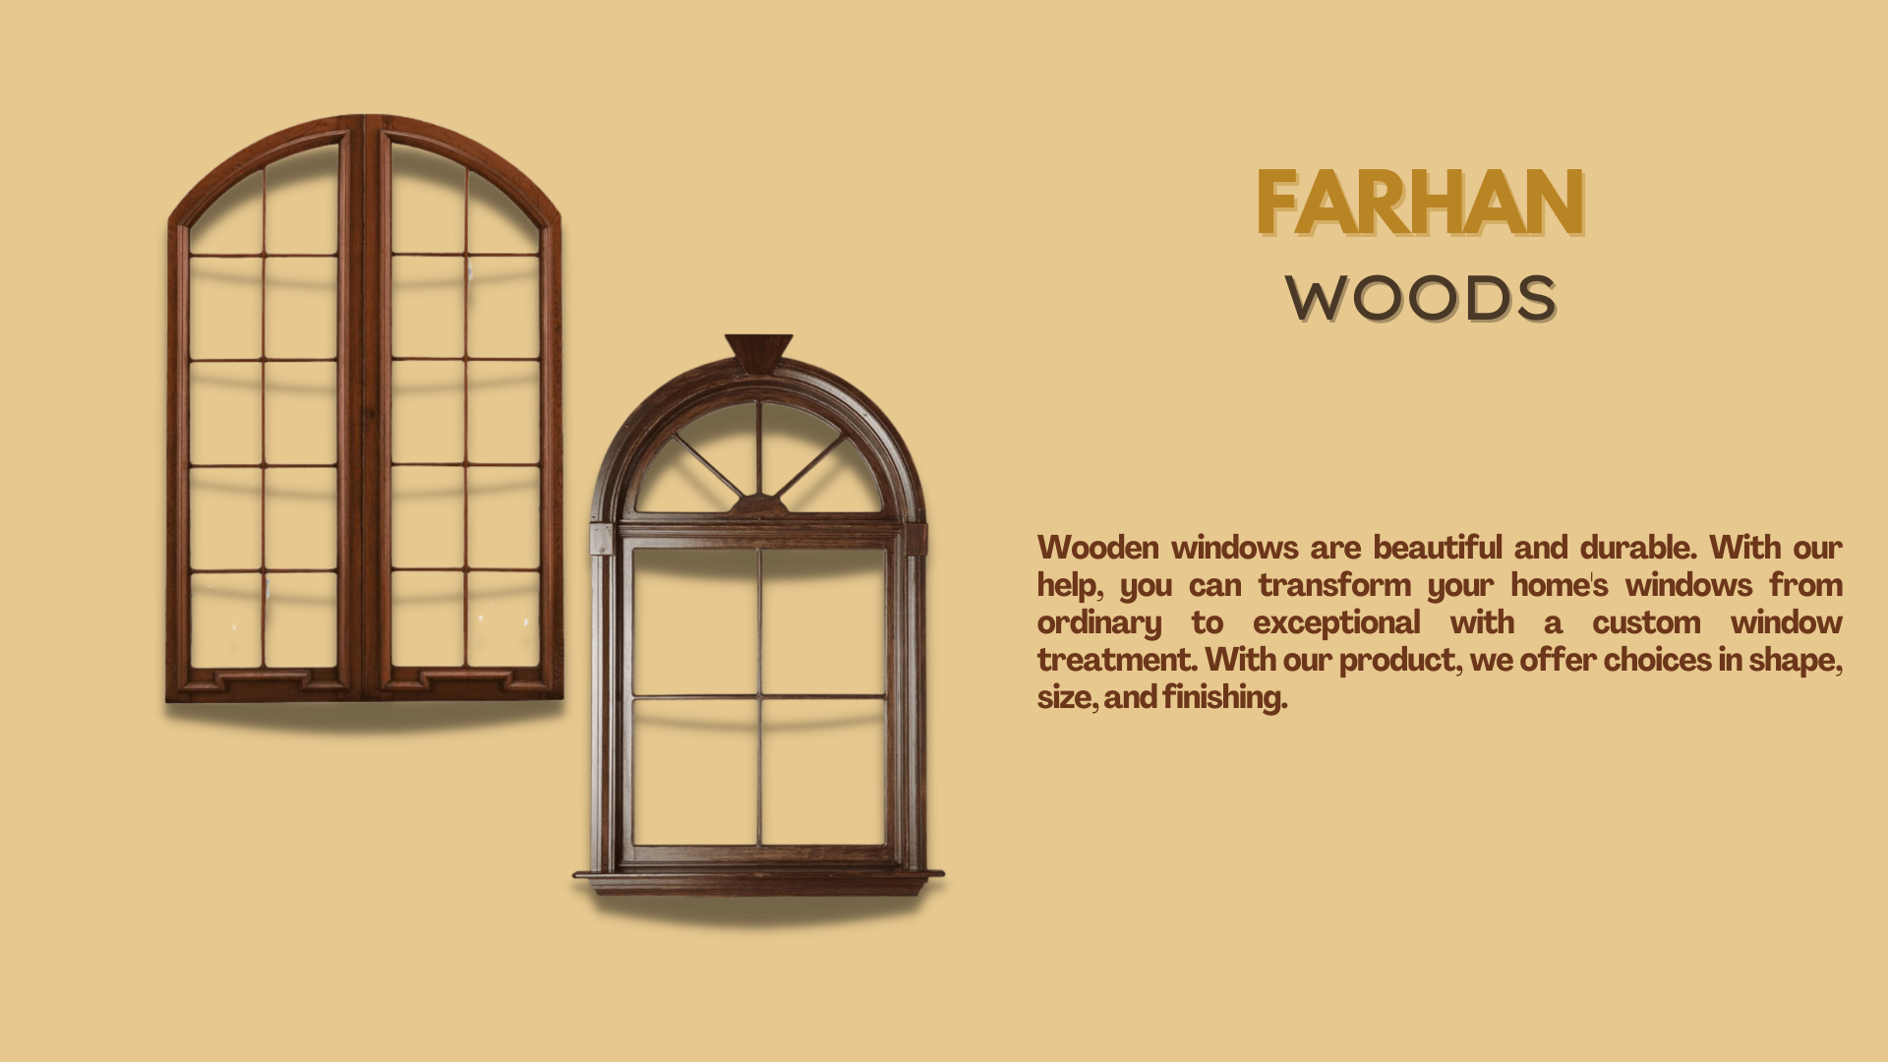

1

|  |  |
| --- | --- |
|  |  |

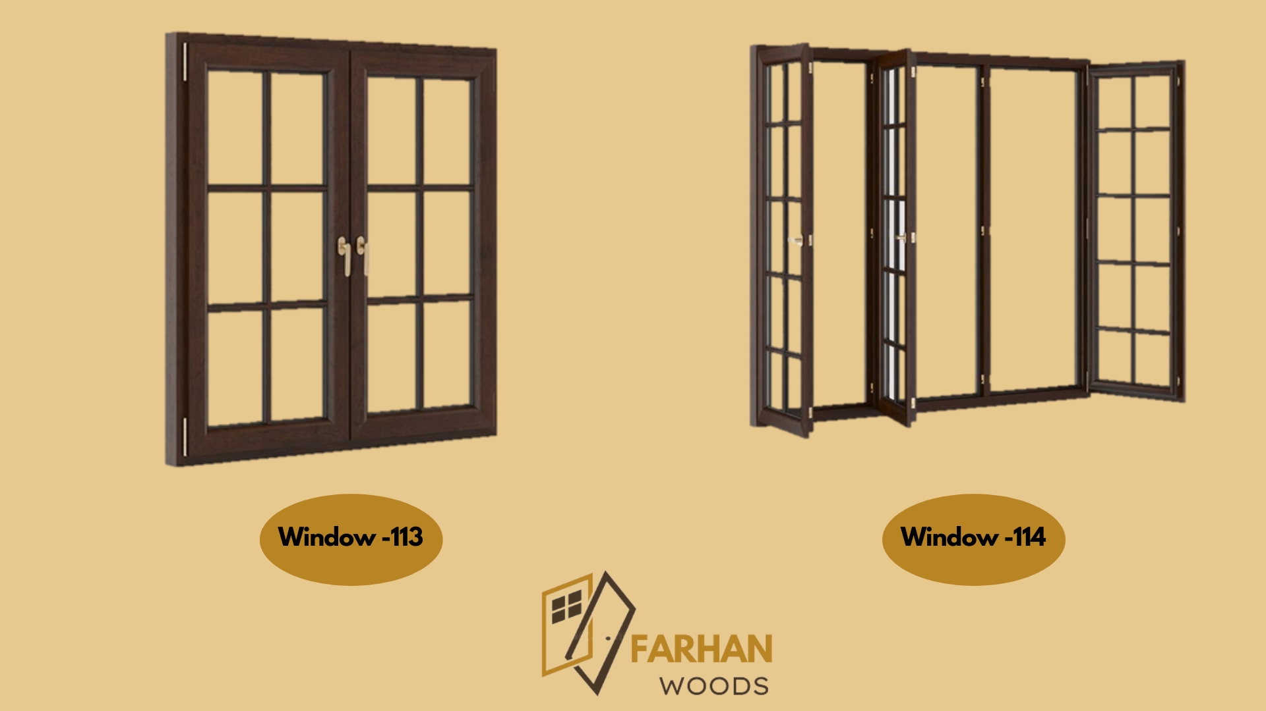

# 

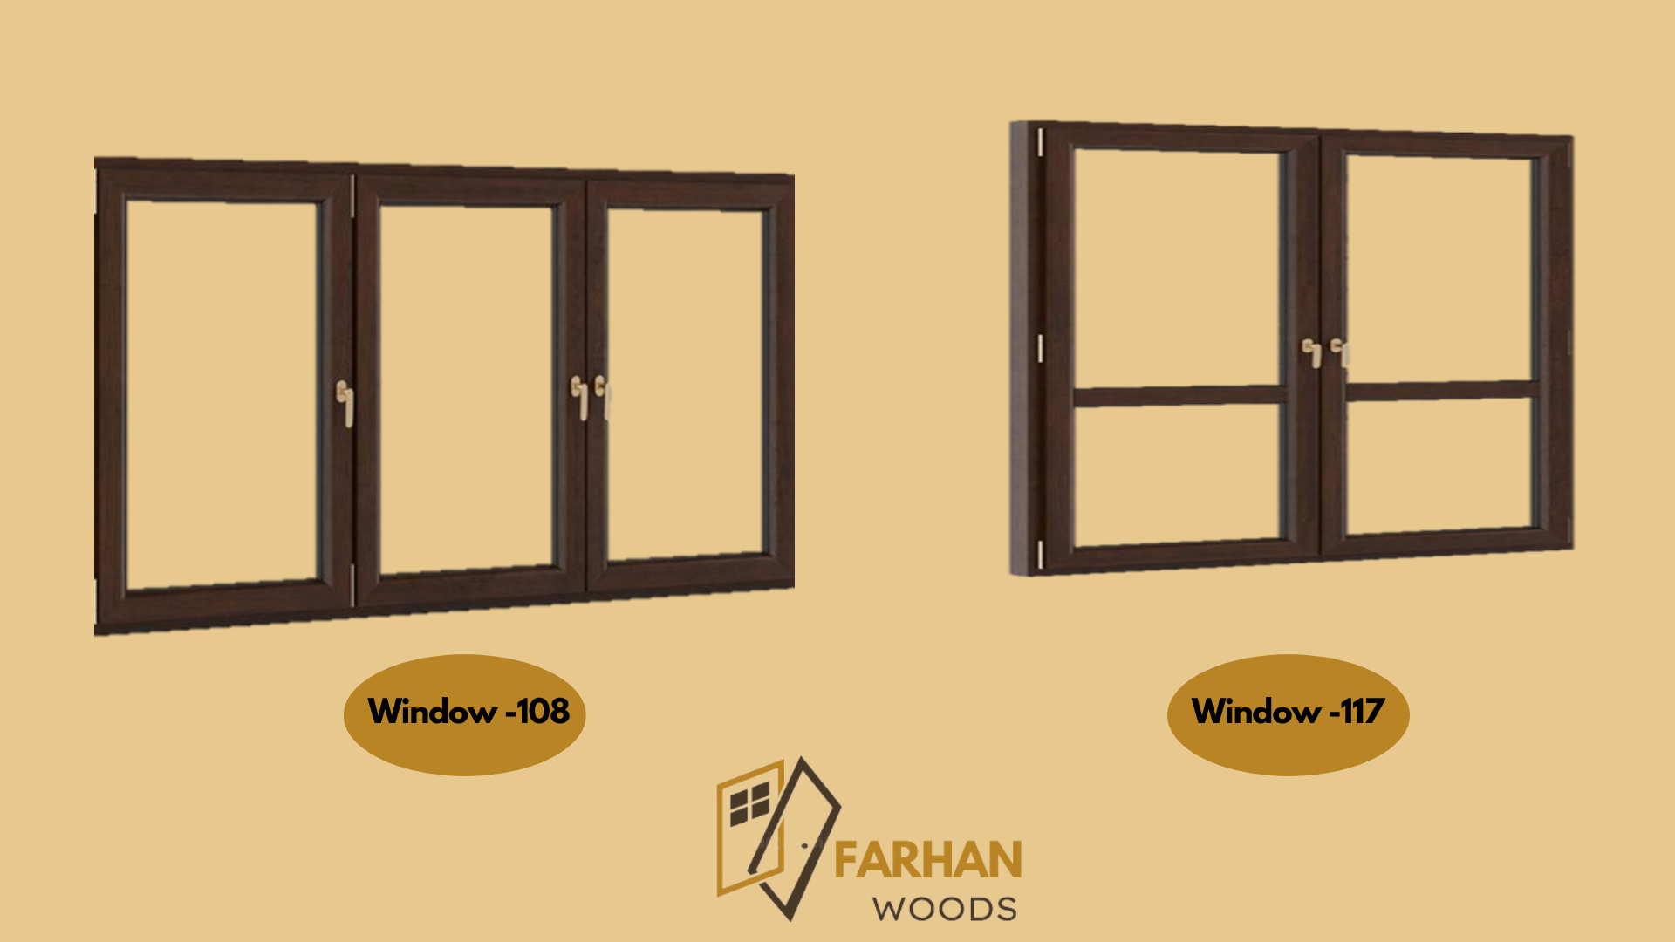

# DOORFRAMES

Doorframes are available in diﬀerent types and sizes. They are anti-corrosion, anti-fungal which make them durable. Water and chemical resistant make them withstand harsh climatic conditions.

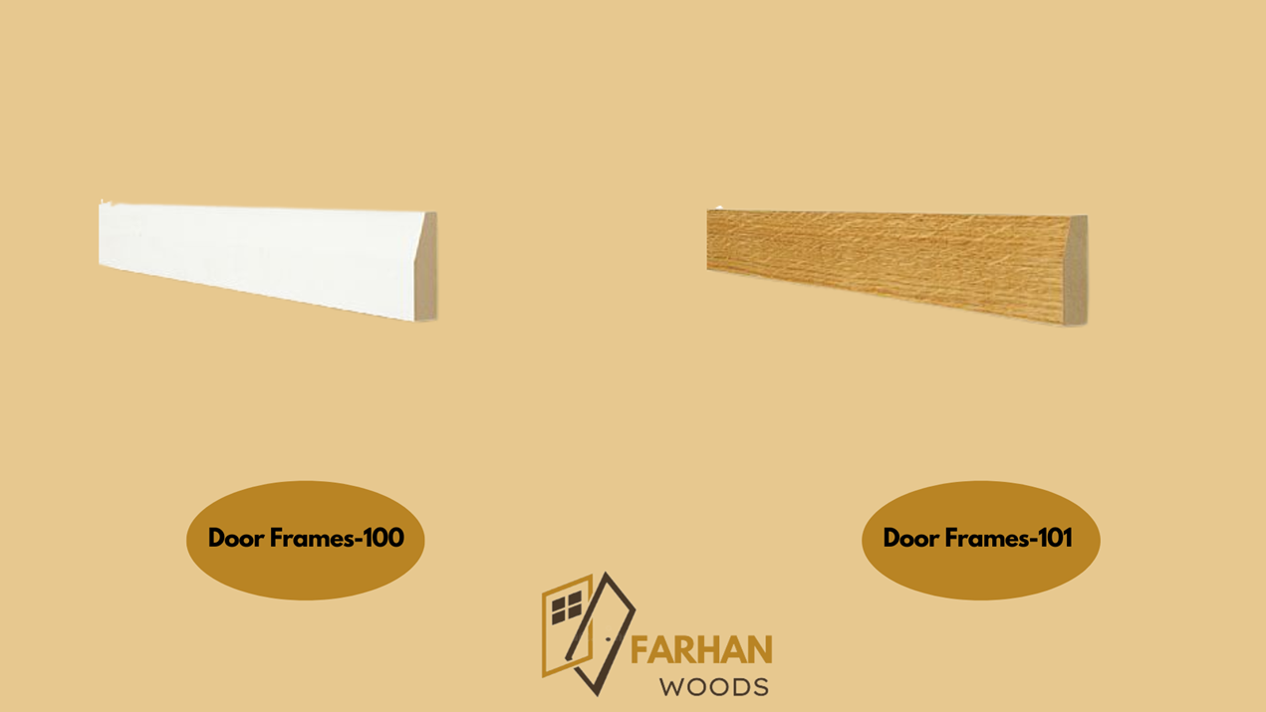

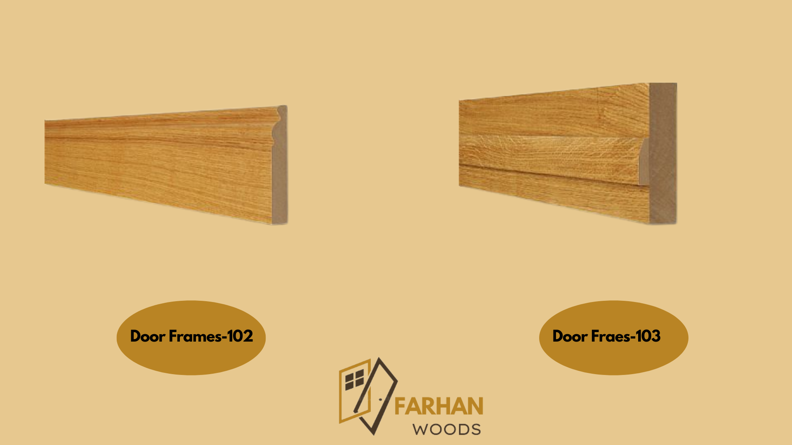

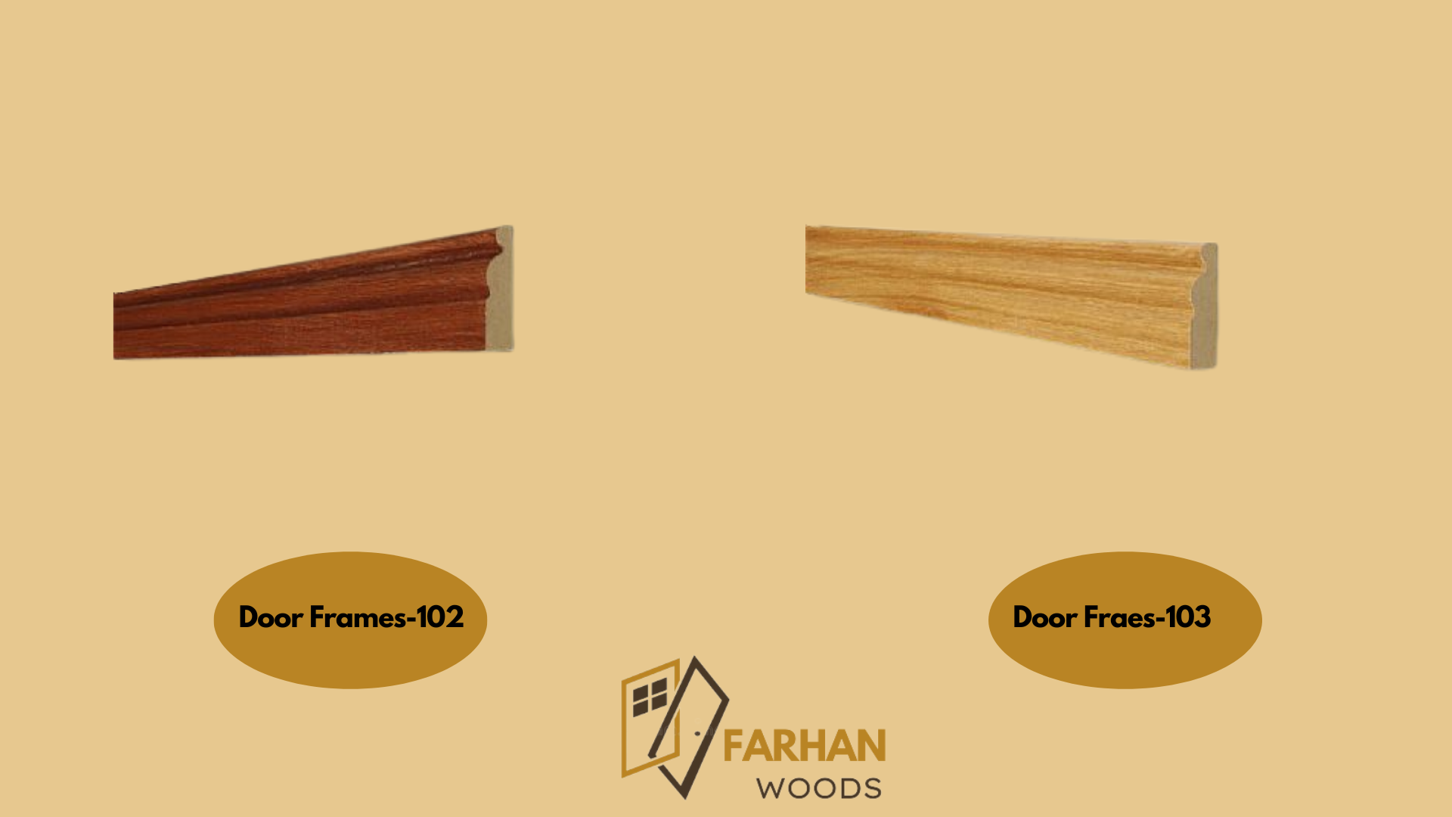4

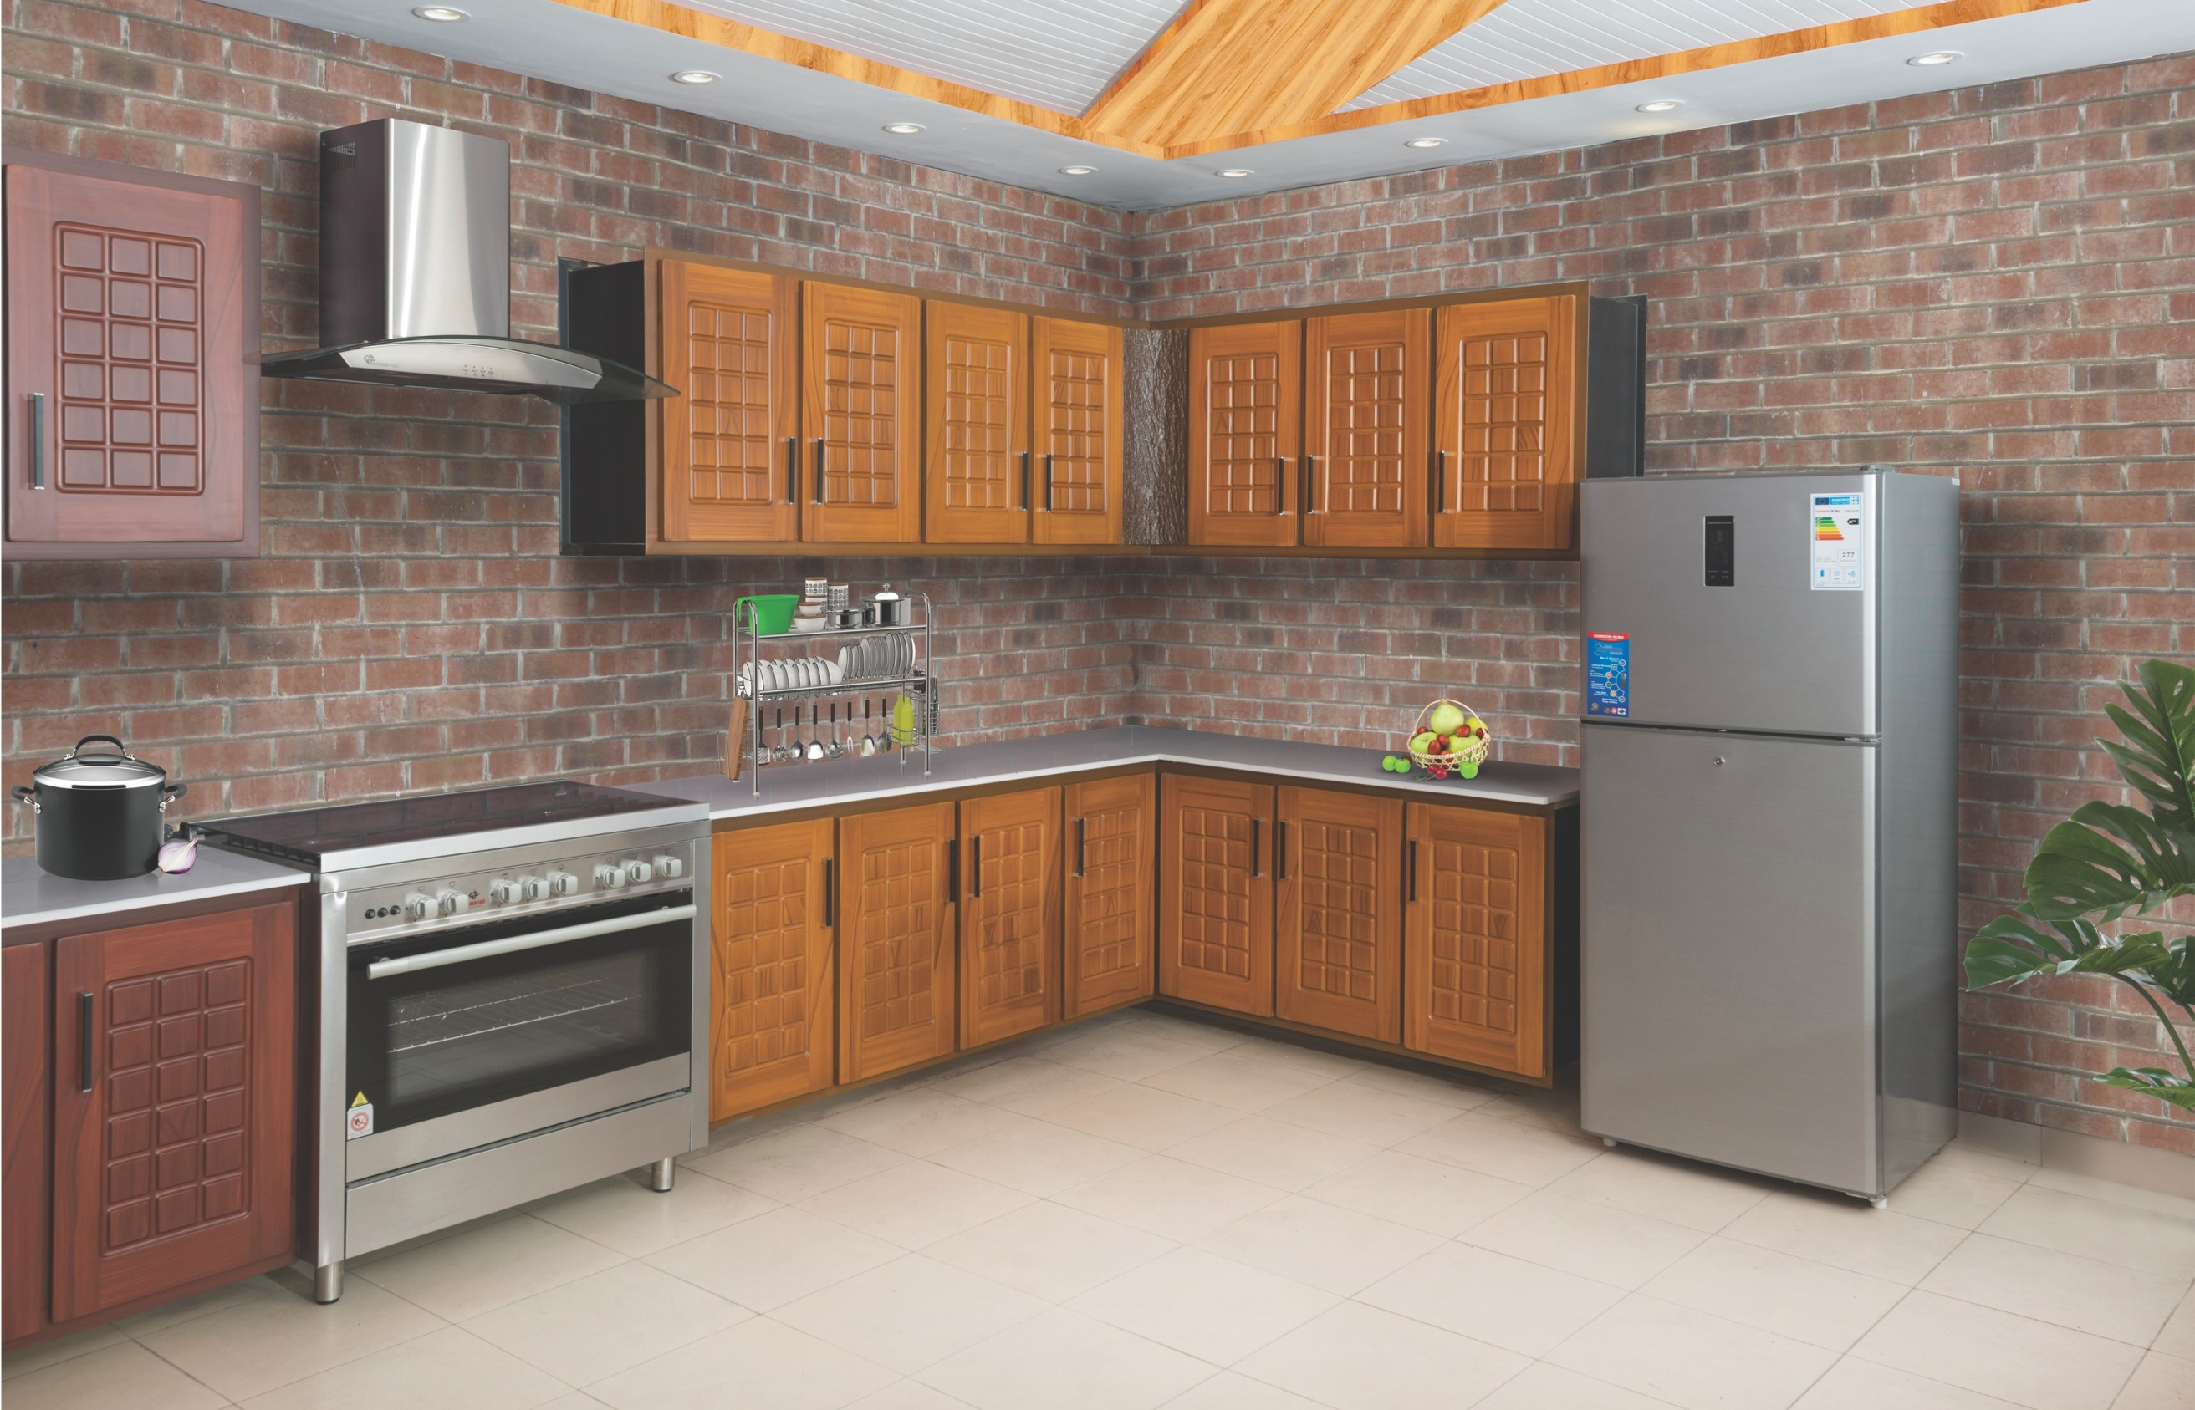

14

# KITCHEN CABINETS

Polydoors Kitchen Cabinets are available in diﬀerent designs and styles. Not just that, they are durable due to their anti-corrosion, anti-fungal and anti-termite properties. They are also chemical and water resistance and are not aﬀected by heat either. They are a perfect ﬁt for your kitchen.

#### Choose the best for your home, Choose Polydoors Kitchens.



**Dimensional stability**



**Reﬂect UV & IR rays**

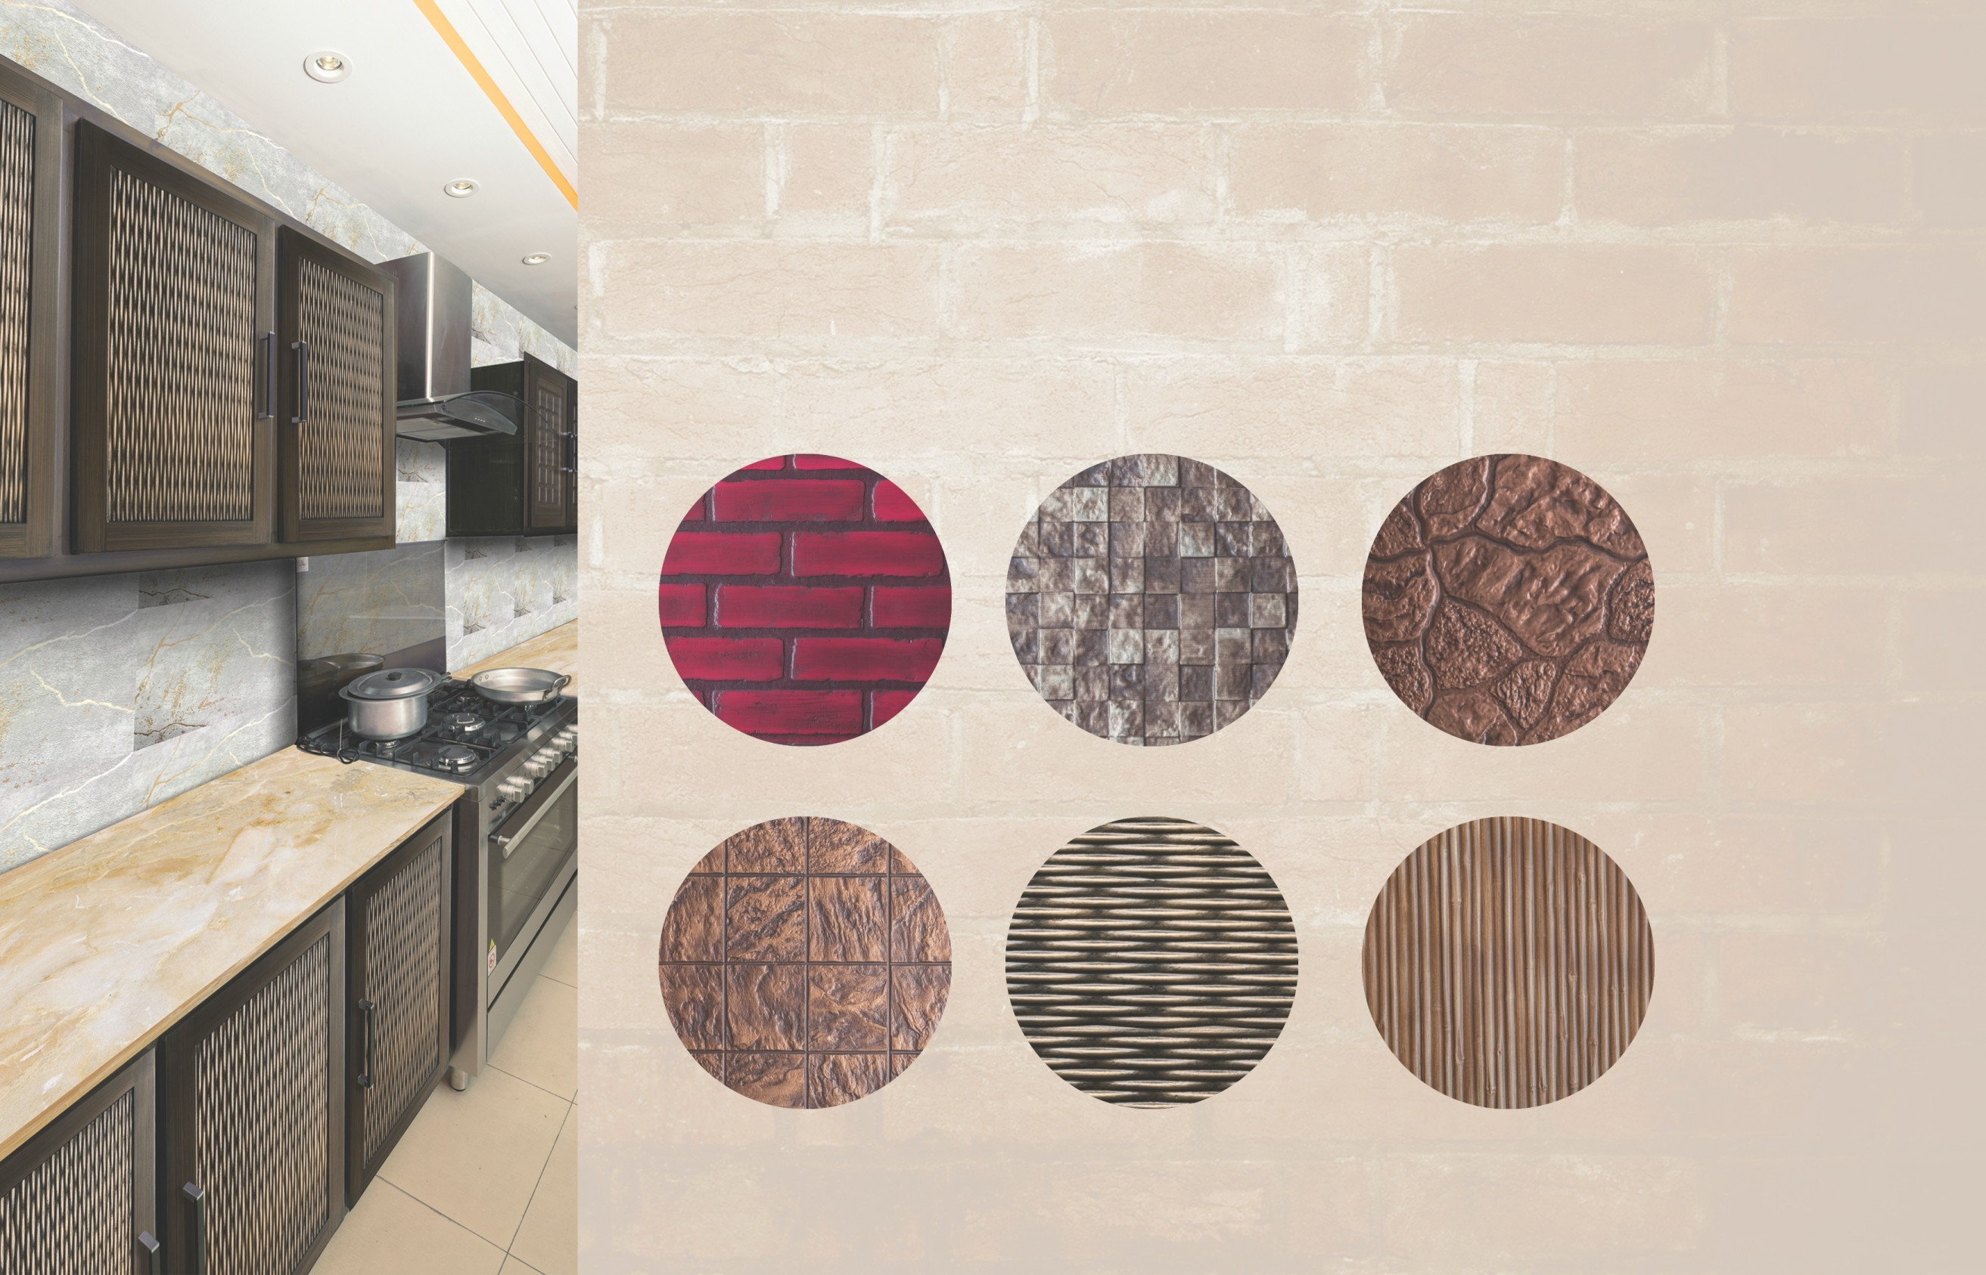



**Durability**

**KP # 05**

**KP # 06**

**KP # 02**



**Colour choice**



**Polished surface**



**Exquisite designs**

15

**KP # 09**

**KP # 07**

**KP # 08**

# BED SETS

Polydoors bed sets are available in diﬀerent designs, textures and colors. They are anti-fungal, anti-termite, corrosion-free which makes them durable and reliable. Water and chemical resistance adds additional characteristics to solidify their strength.

16

# WARDROBES & CUPBOARDS

Polydoors wardrobes and cupboards are made of composite material and they last longer than any wooden or conventional material. They are available in diﬀerent designs, colors and textures.



**Dimensional stability**



**Reﬂect UV & IR rays**

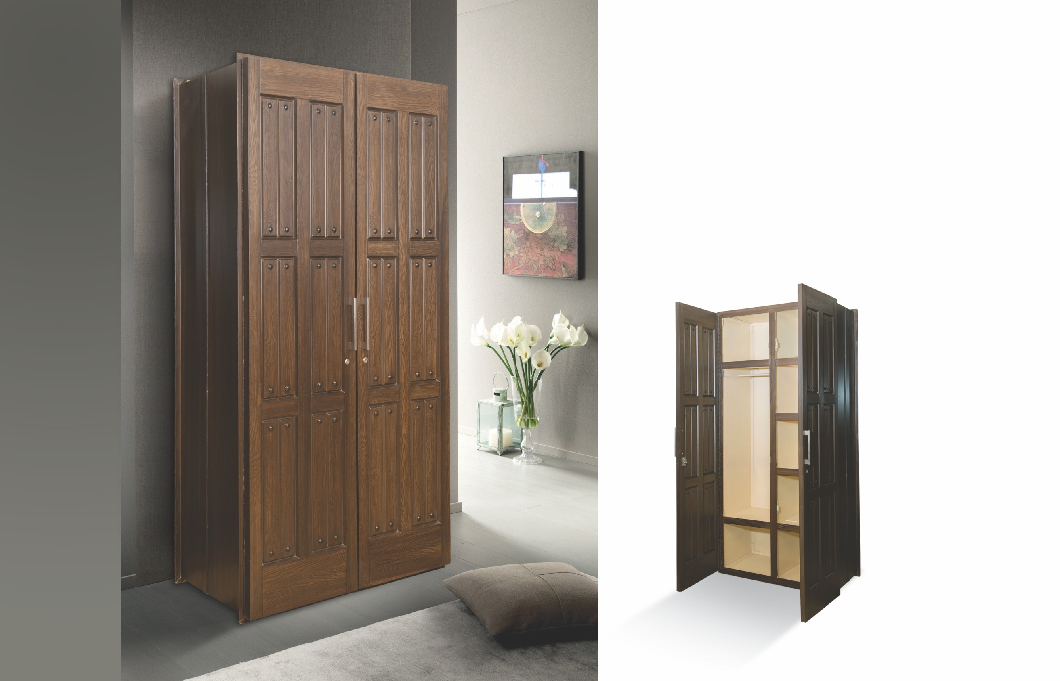



**Durability**



**Colour choice**



**Polished surface**



**Exquisite designs**

17



**Dimensional stability**

# MAIN GATES

Polydoors main gates are available in diﬀerent designs, textures and colors. They are anti-fungal, anti-termite, corrosion-free which make them totally weather-proof. Water and chemical resistance characteristic further solidify their strength.

**Best gates for your home.**

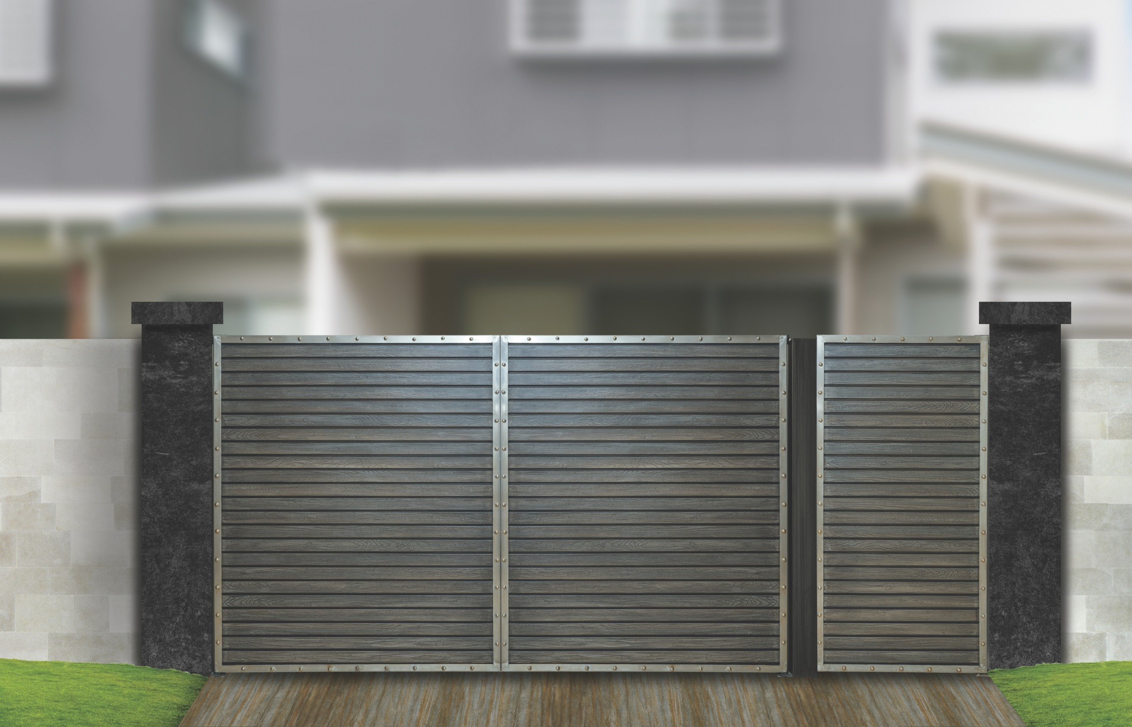



**Reﬂect UV**

**& IR rays**



**MG # 01**

**Durability**



**Colour choice**



**Polished surface**



**Exquisite designs**

18

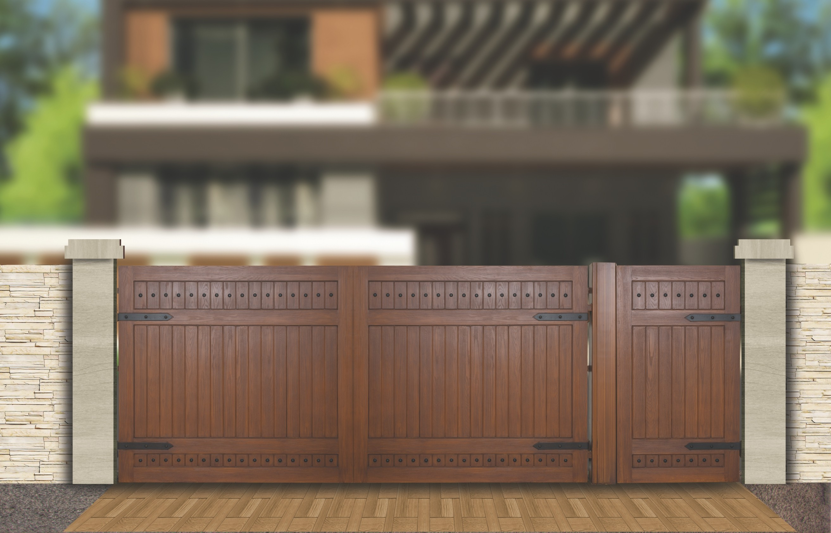

**MG # 02**

19



**Dimensional stability**



**Reﬂect UV & IR rays**



**Durability**

# GUARD ROOMS

Polydoors Guard Rooms/Check-Posts are used for diﬀerent industrial as well as commercial purposes. Our portable cabins are made of three layers; a hard polymeric foam sheet core, a face and back layer of 2 mm thick ﬁberglass sheet and are relatively more cost eﬀective. These portable cabins can easily bear extreme weather conditions and high intensity tremor. Owing to their features like weather resistance, compact design, durable ﬁnish standards, aesthetic look and easy installation, these Guard Rooms

/Check-Posts are highly demanded across the country.

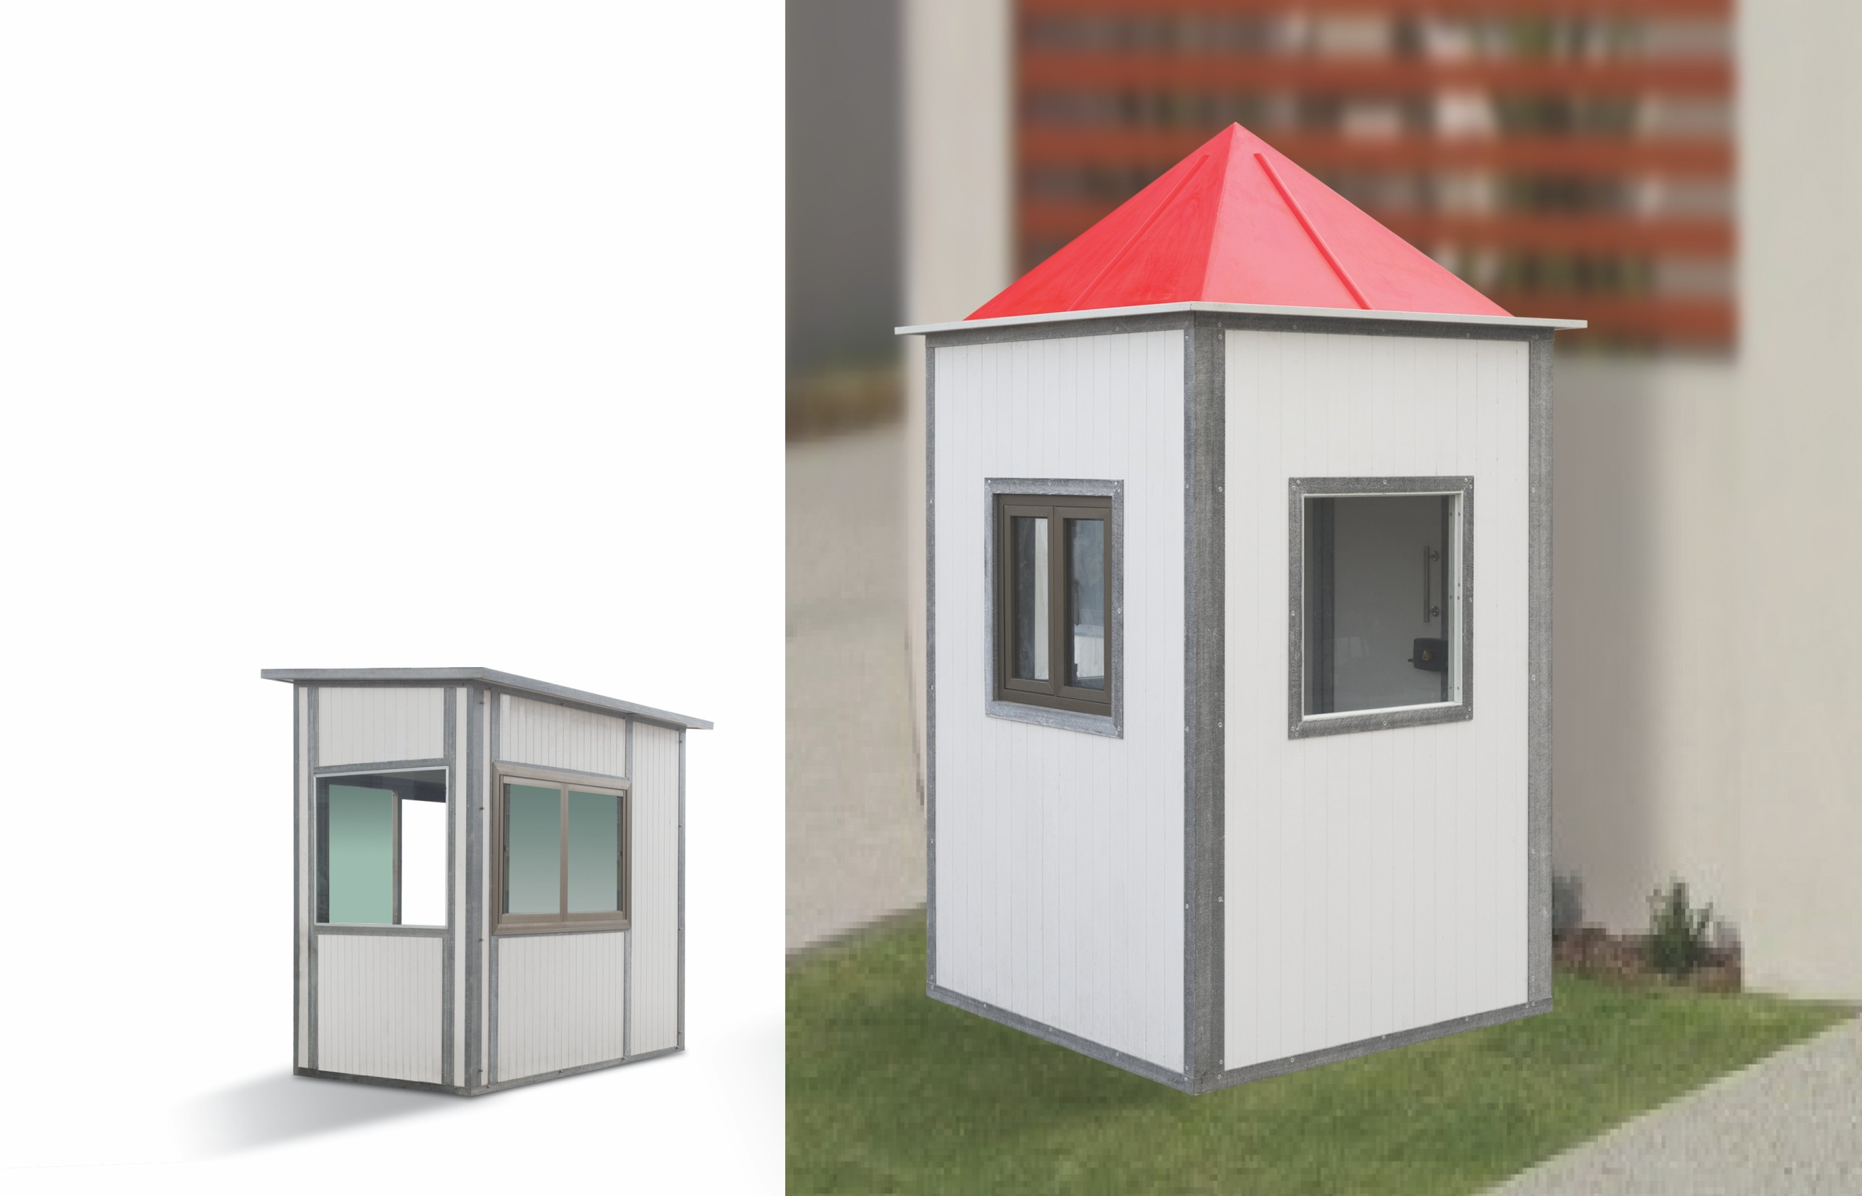



**Colour choice**



**Polished surface**



**Exquisite designs**

20

# POLYDOORS FIBERGLASS READY FIX CABINS & HUTS

Polymer Industries, the manufacturers of Polydoors, have introduced prefabricated ﬁberglass panels made of ﬁberglass sheets and sandwiched in between hard polymeric foams. The combination produces very high quality, strength and highly insulating panels of various dimensions. These panels can be assembled quickly to cabins, guard rooms, check-posts and other desirable cabins and big boxes. These panels are also an ideal solution for the hilly areas, small houses and will work as earth quake proof building blocks.

The products are assembled in a way in which they can be dismantled and reassembled as desired within a short period. These panels are an ideal solution for strong and sound proof partitioning of big halls and rooms to small cabins etc.

21

# FEATURES

Light weighted and portable Convenient to install Durable and very long usable life Resistance to harsh weather conditions Decorative

Free from corrosion

22

# PROPERTIES OF FIBERGLASS QUICK FIX WALL PANELS

The wall panels are made of three layers; a hard polymeric foam sheet core, a face and back layer of 2 mm thick ﬁberglass sheet in many designs. The wall sandwich panels are used in application where a combination of high structural rigidity and low weight is required. We provide these ﬁberglass panels of any desirable size with a maximum dimension of 8ft x 8ft (2.44 m x 2.44 m); the thickness of the panels is approximately 2 inch (49 mm).

From these panels, cabins of virtually any size can be assembled. These panels are available in a very economical price.

Close Section

(Door / Window Section) Extension Section

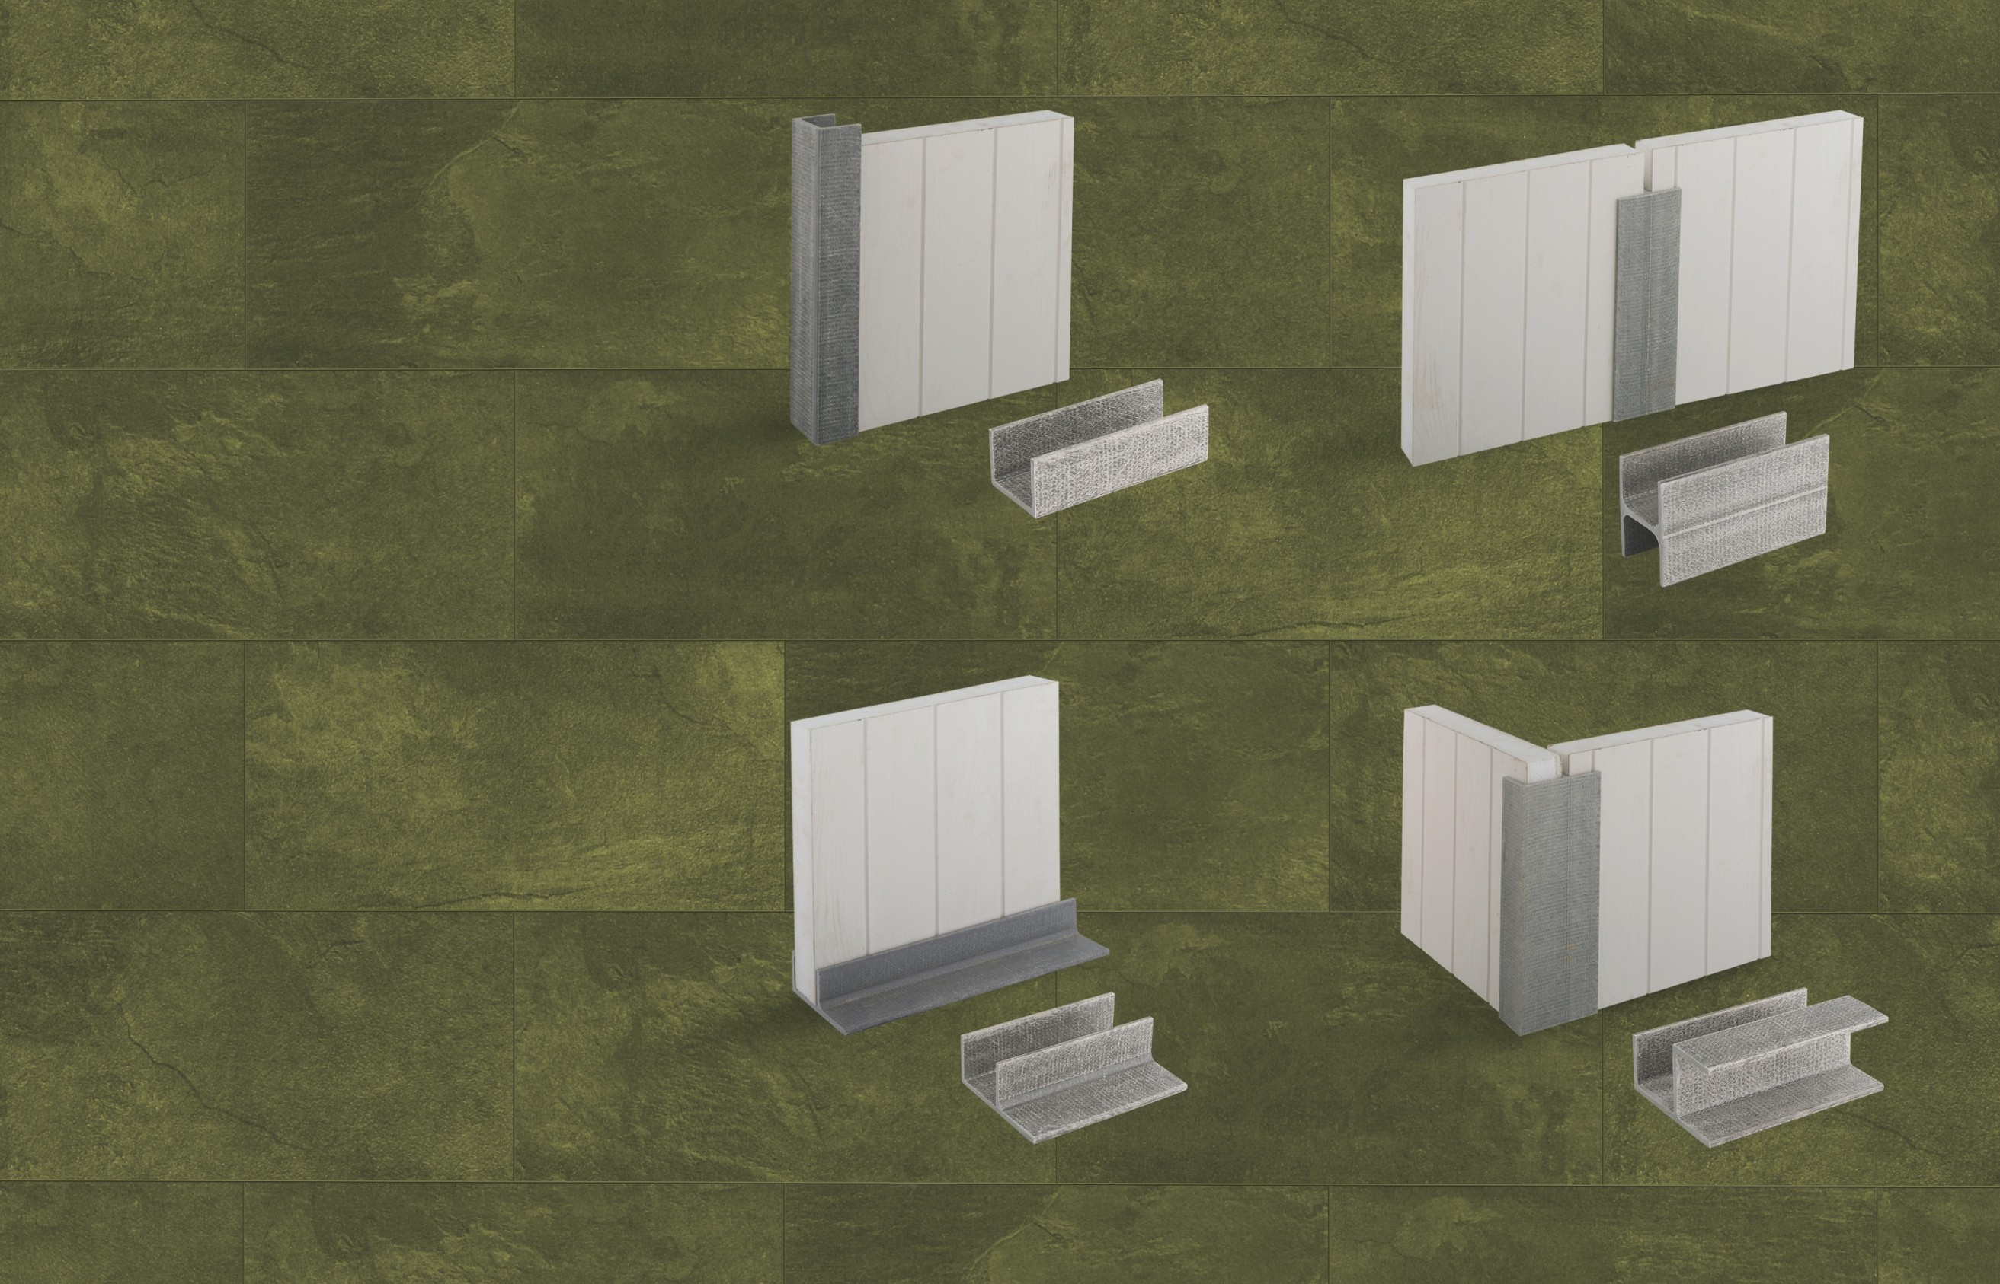

Base Section Corner Section 23

# FIBERGLASS PULTRUDED PROFILES & CHANNELS

These channels are used for combining diﬀerent panels to make the desired shapes.

### Bar

20 mm Dia

### Tube #1

53 mmx77 mm

### Tube #2

51 mmx18 mm

### C - Channel

83 mmx30 mm

### Tube #3

76 mmx18 mm

### Angle

38 mmx38 mm

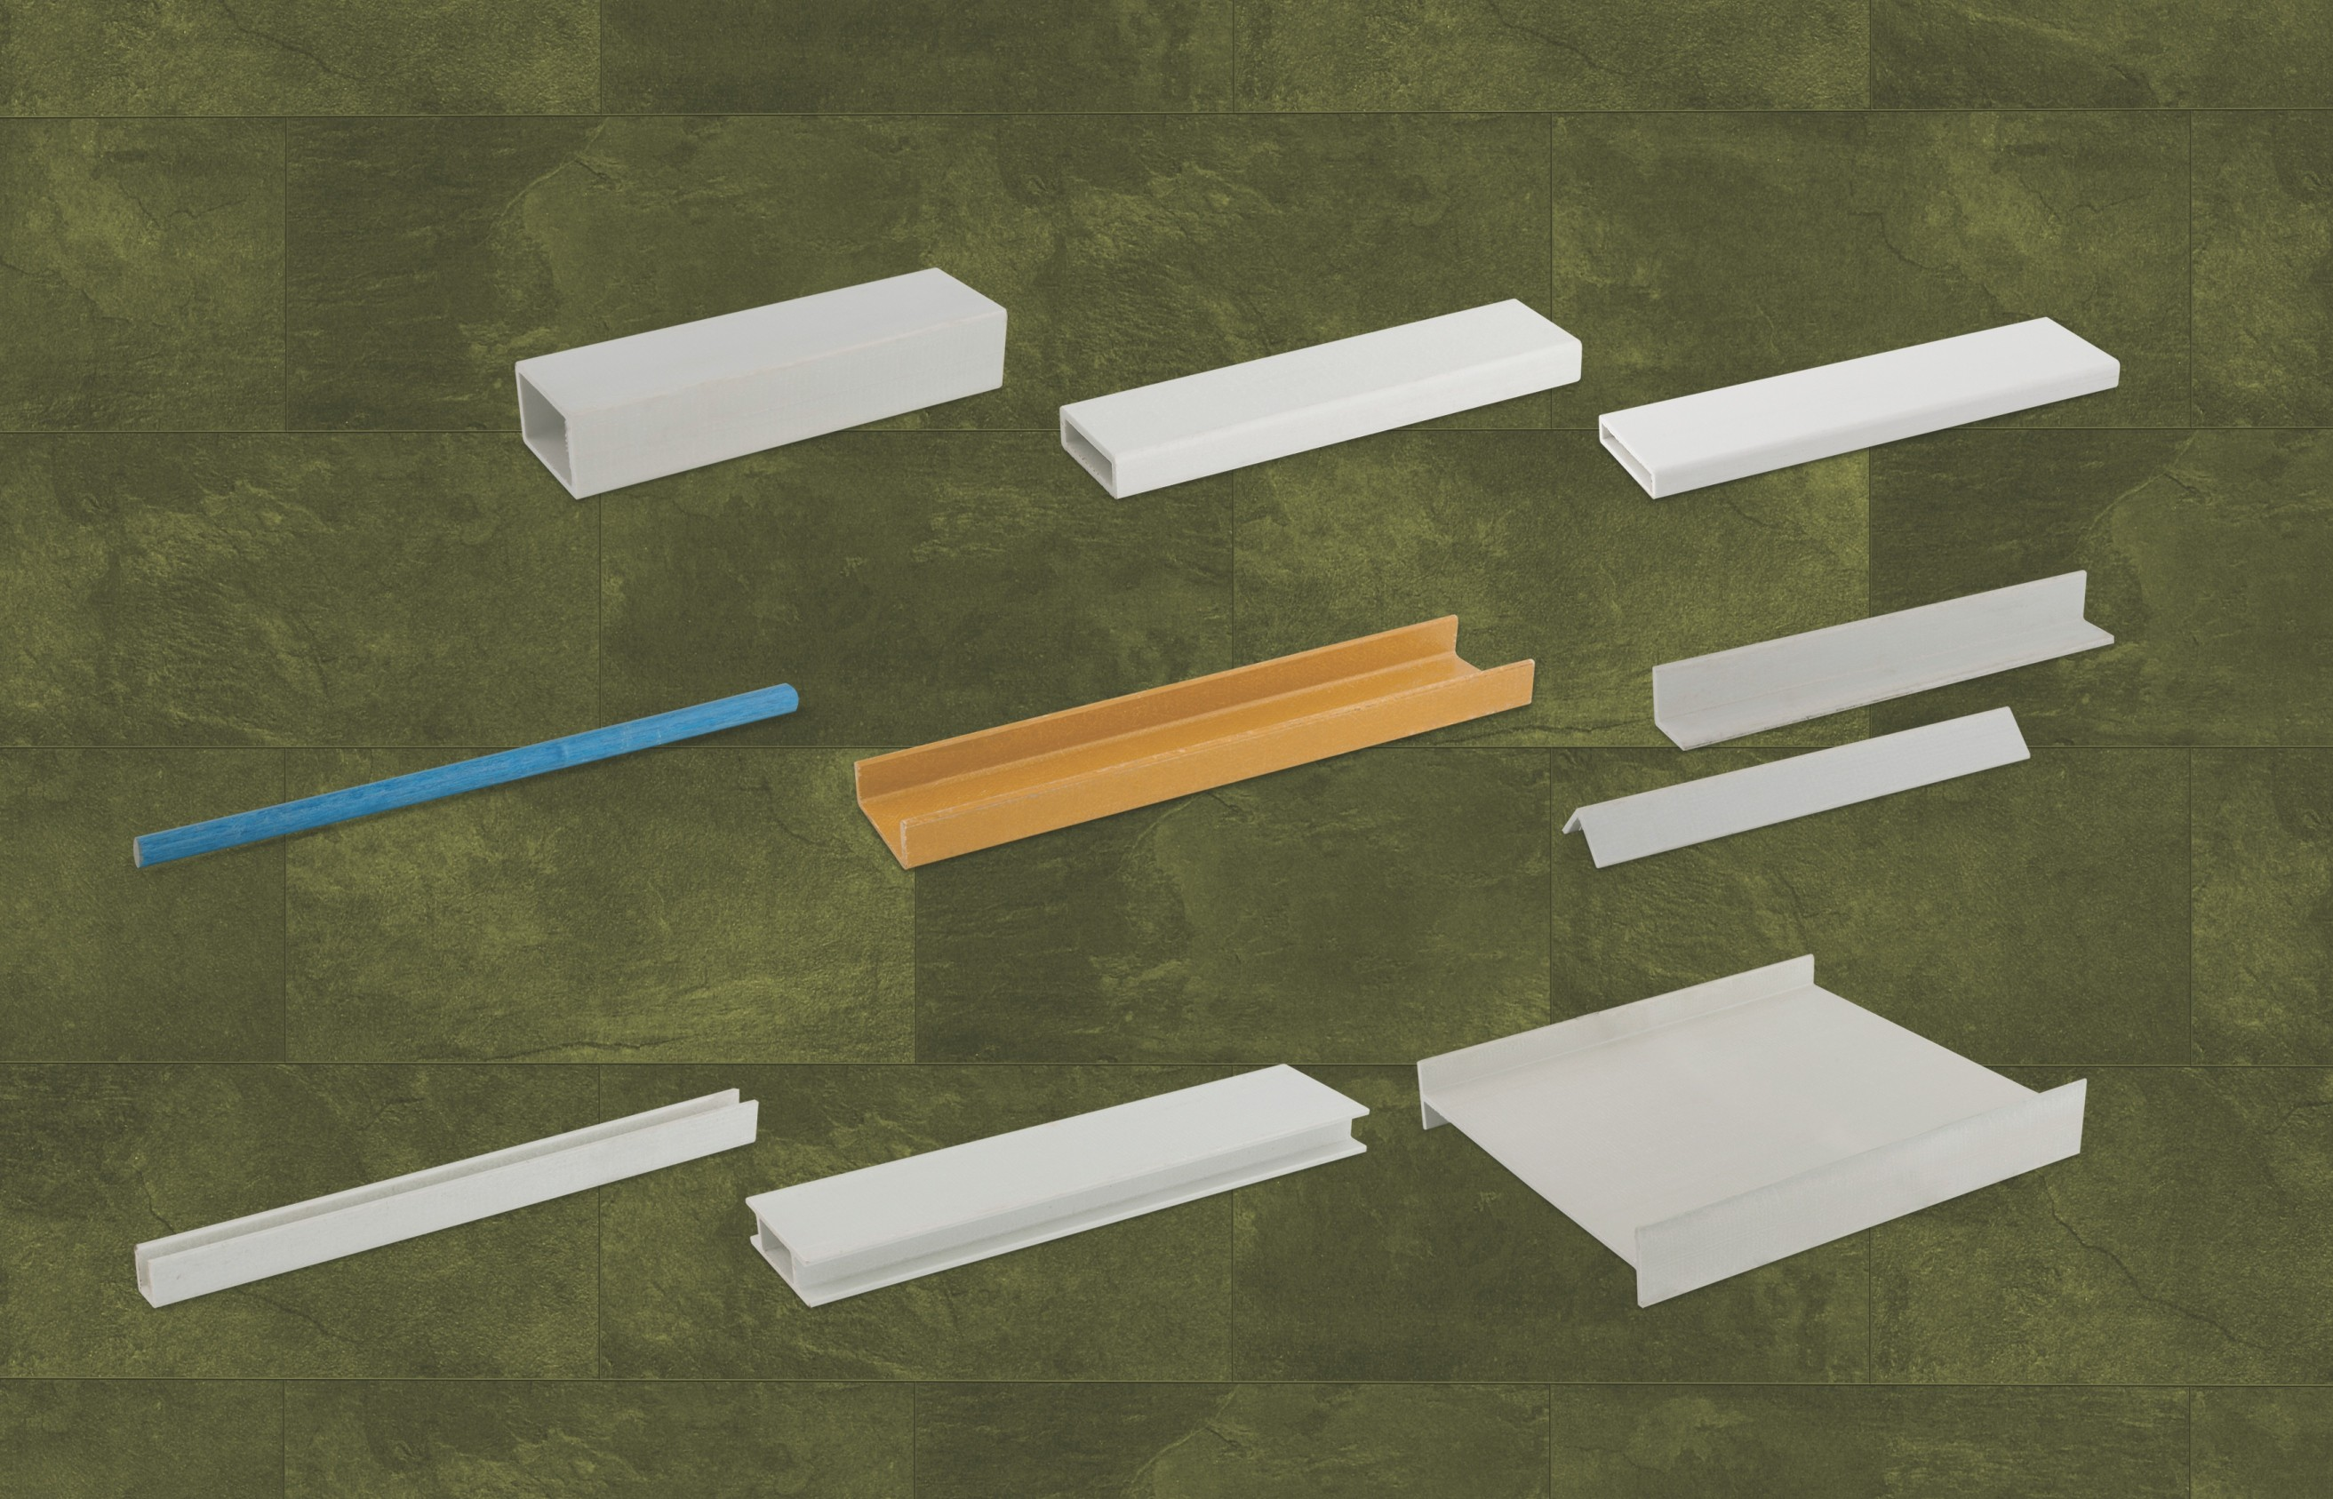

### U - Channel

24 38 mmx38 mm

### Double H - Channel

102 mmx34 mm

### Single H - Channel

356 mmx63 mm

**CHEMICAL STRUCTURE**

**Composite Material Support Fill Up**

**Inside Hard Composite Material Approx.**

**4”~6”**

**Fibre Glass Sheet**

We have the rights to change any specification of our products without any prior notice.

**BUILT IN COLORS**

**Color Code 4010**

**White**

**Color Code 4020**

**Sky Blue**

**Color Code 4030**

**Cream**

**Color Code 4040**

**Pink**

**Color Code 4050**

**Grey**

**Color Code 4060**

**Seige Green**

**Color Code 4070**

**Peach**

**Color Code 4080**

**Ivory**

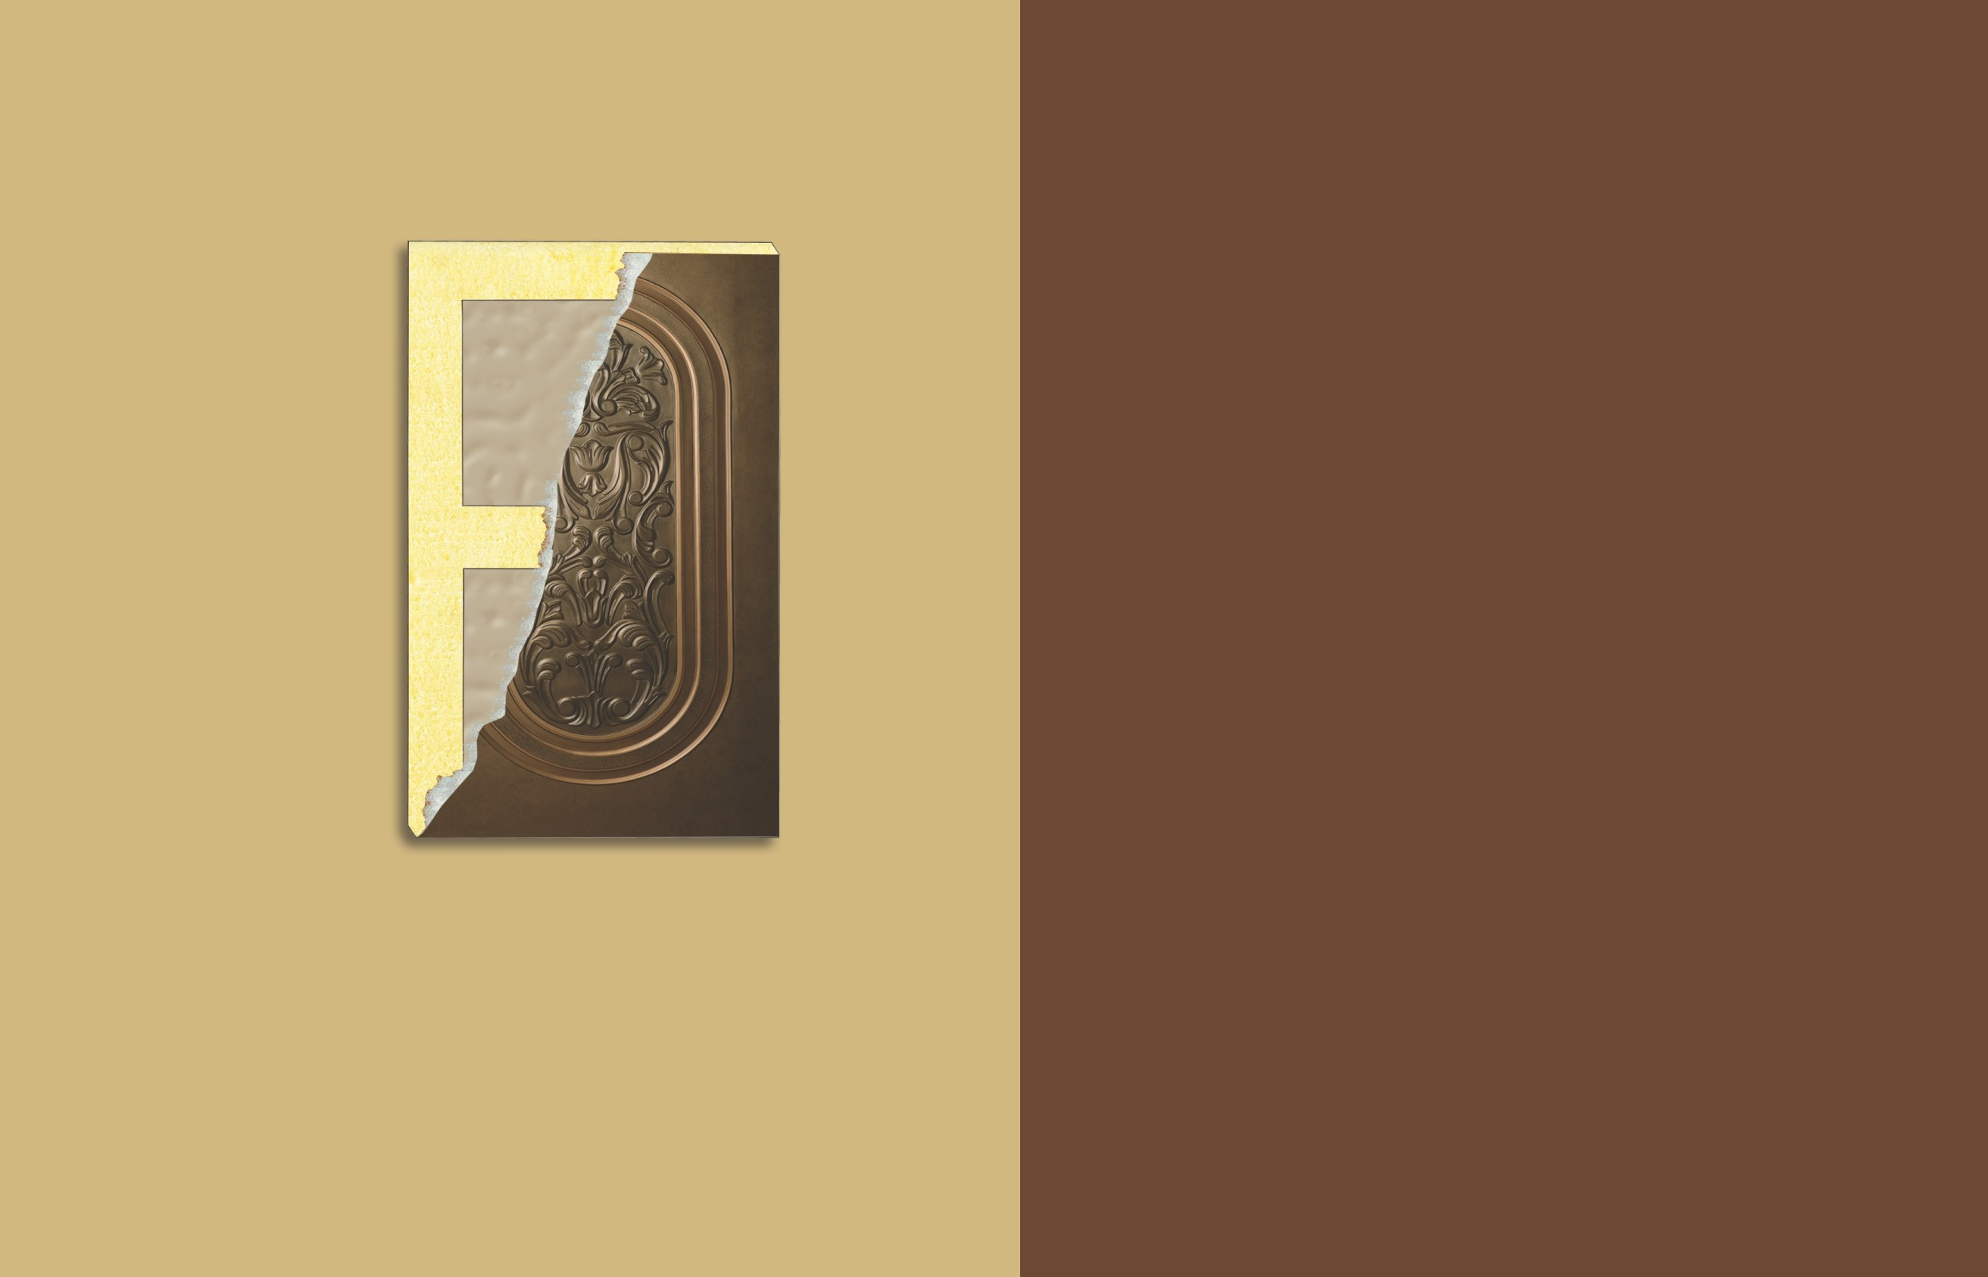Printed colors may differ from actual colors



polydoors.com.pk

#### GUJRANWALA 1

**OUTLETS**

Bypass Road, Near Qila Chand Contact: 0345-8478178 / 0300-0540068

#### GUJRANWALA 2

Opposite Iqbal High School, G.T. Road, Contact: 0300-6423468

#### GUJRANWALA 3

Opposite HBL, Gondlanwala Road. Contact: 0300-0569241-42

#### SIALKOT

Doburji Malihan, Daska Road, Sialkot. Contact: 0345-9648972

#### ZAFARWAL



Near PTCL Exchange, Chawinda Road. Contact: 0331-4688888

#### LAHORE 1

30-1-Cll, Near Ghazi Chowk Main College Road, Township. Contact: 042-35155656 - 35156700

#### LAHORE 2

Office #13, Sector F, Askari 10, Lahore Cantt. Contact: 0321-4642444 / 0321-5348087

#### ISLAMABAD

Jan Plaza, Opp. DHA Phase II, Gate # 2, Main G.T. Road. Contact: 051-5709392 / 0303-2224433

#### FIASALABAD

Chen One Road, Near Al-Fateh Sports Club. Contact: 0303-2224422

#### FIASALABAD 2

Pensra Dajkot Road, 79-JB (ADDA) Contact: 0313-2676481 / 0302-6022683

**HEAD OFFICE**

#### JHELUM

**LALAMUSA**

45/A-46-A, S.I.E. #2, Gujranwala, Pakistan Tel: +92 55 4283913-14

Fax: +92 55 4286413

E-mail: [info@polydoors.com.pk](mailto:info@polydoors.com.pk)

#### [www.polydoors.com.pk](http://www.polydoors.com.pk/)

G.T. Road, Mujahidabad. Contact: 0344-5675488

#### MIRPUR

Mian Muhammad Road. Contact: 0300-9182031

Al-Baig Plaza, G.T. Road. Contact: 0300-5422018

#### GUJJAR KHAN

Railway Road, Gujjar Khan. Contact: 0300-9505812